Page 1 Name ___________________ Class ___ - ___
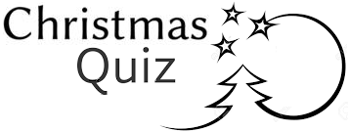
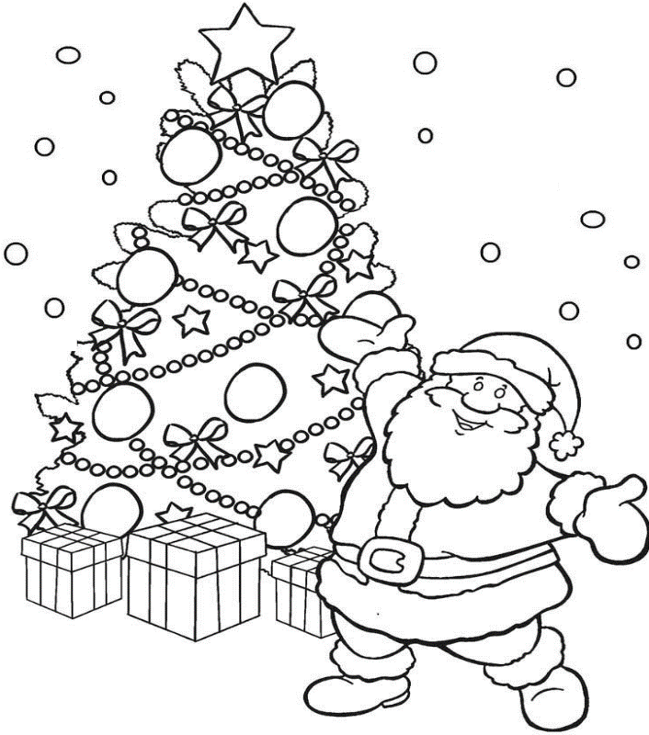

1. He is a fat, happy man who gives children presents.
A N T S A S __ __ __ __

2. Something shiny which we put on the Christmas Tree

R A T I O N C O D E D __ __ __ __ __ __ __ __ __

3. Something that falls from the sky when it is cold.

W O N S S __ __ __

4. This is a decoration which we put on the top of the Christmas tree.

R A T S S __ __ __

Page 2 Name ___________________ Class ___ - ___

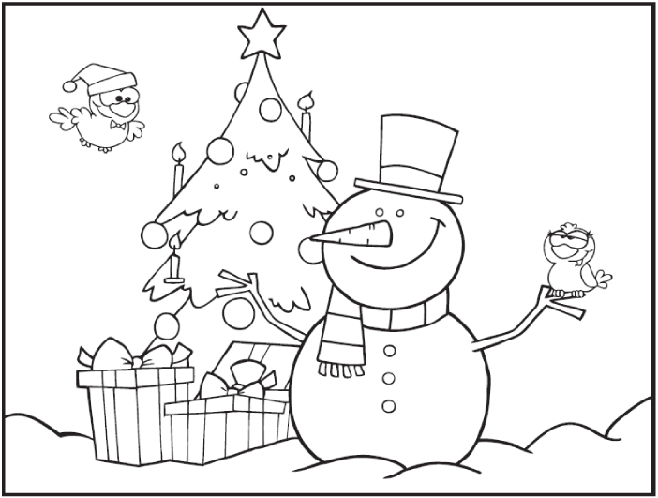
5. This is something that you wear on your head.

T H A T __ __

6. Something that you get at Christmas and birthdays.

S E R P E N T P __ __ __ __ __ __

7. Something that you use to tie a bow around gifts. What is it?

R O B I N B R __ __ __ __ __

8. Something that has a triangle shape. It is green, tall and has lights?

R E E T T __ __ __

9. This is a character who is fat and cute and is made from snow.

W O M A N S N S __ __ __ __ __ __
Name ___________________ Class ___ - ___

1 | 2 | 3 | 4 | 5
 |  | 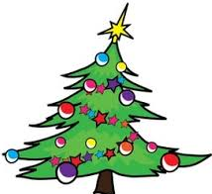 | 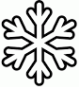 | 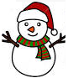
( ) | ( ) | ( ) | ( ) | ( )
a | b | c | d | e
Snowman | Present | Santa | Tree | Snow
6 | 7 | 8 | 9
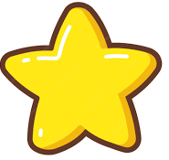 | 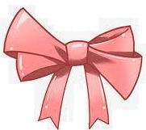
( ) | ( ) | ( ) | ( )
f | g | h | i
Hat | Decoration | Star | Ribbon

