Camping Trip!

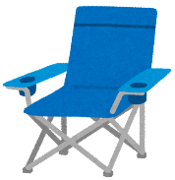

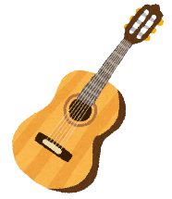
torch
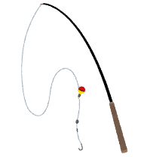
camping chair
sleeping bag
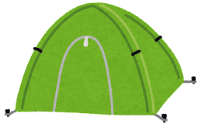

guitar
tent
fishing rod

Think and write
What should you bring? Write three ideas.
例: some matches | Because we can make campfires.
1.
2.
3.

Share with your group. What should you bring? Decide together.
Name | Idea 1 | Idea 2 | Idea 3

Writing challenge!
例: We should bring some matches.
Because we can make campfires.

- We should
Because

- We should
Because

- We should
Because

