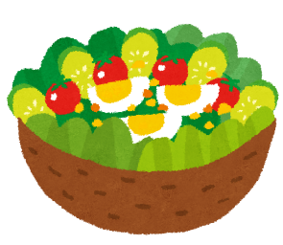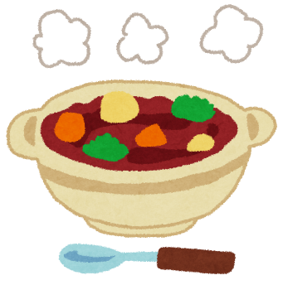

Unit 6

This is my...

stew! ・ salad!

Name:________________________Class:_____________Date:______________

Place:

(from page 56-57)

Ingredients:

(from page 56-57)

|  |  |  |
| --- | --- | --- |
|  |  |  |
|  | from |  |
|  |  |  |
|  |  |  |

