Hi, how are you?

I’m fine, thanks, and you?

I’m good, thanks.

When is your birthday?

My birthday is August 5th.

Cool. What cake do you want?

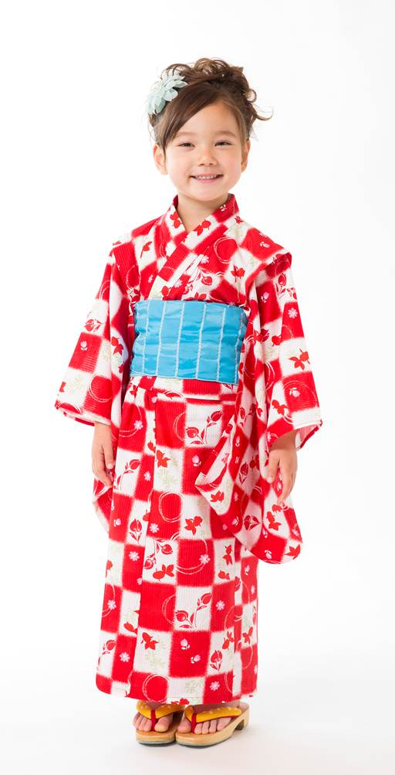
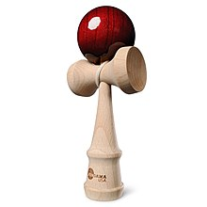
I want an ice cream cake.

Cool. I like ice cream cake.

When is your birthday?

My birthday is January 17th.

Really? What party do you want?

