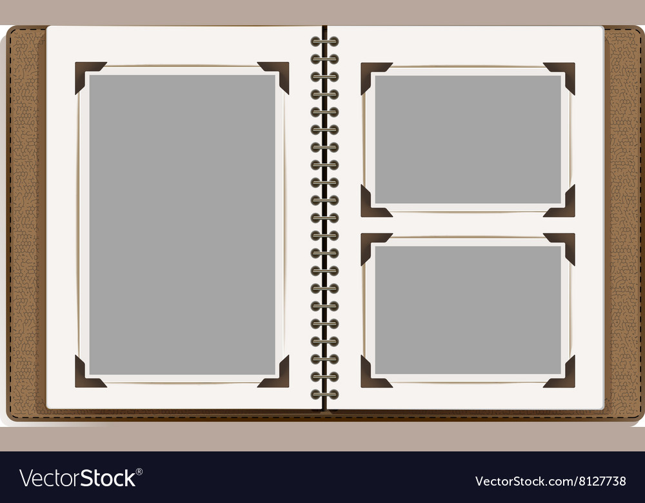

**My Summer Vacation**

I went to

It was

I ate

I enjoyed