My Daily Routine
Name  Country | _____________  _____________ | _____________  _____________ | _____________  _____________ | _____________  _____________
get up
eat breakfast
go to school
study English
eat lunch
go home
do your homework
eat dinner
take a bath
go to bed

Name: Marissa
Country: India
get up | 7:00am
eat breakfast | 7:15am
go to school | 8:00am
study English | 11:25am
eat lunch | 12:35pm
go home | 3:50pm
do your homework | 4:30pm
eat dinner | 7:00pm
take a bath | 8:40pm
go to bed | 9:05pm

A: Hello. What’s your name? B: Hello, I’m _____________. And you?
A: Nice to meet you. Where are you from? B: I’m from _________. How about you?
A: I’m from __________.

A: What time do you ~~? B: I ~~ at ________am/pm.
My Daily Routine
Name  Country | _____________  _____________ | _____________  _____________ | _____________  _____________ | _____________  _____________
get up
eat breakfast
go to school
study English
eat lunch
go home
do your homework
eat dinner
take a bath
go to bed
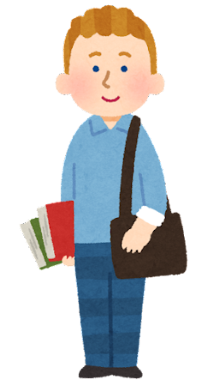

Name: Magnus
Country: Sweden
get up | 5:30am
eat breakfast | 6:00am
go to school | 7:35am
study English | 10:05am
eat lunch | 12:20pm
go home | 3:15pm
do your homework | 4:00pm
eat dinner | 6:50pm
take a bath | 7:25pm
go to bed | 8:00pm

A: Hello. What’s your name? B: Hello, I’m _____________. And you?
A: Nice to meet you. Where are you from? B: I’m from _________. How about you?
A: I’m from __________.

A: What time do you ~~? B: I ~~ at ________am/pm.
My Daily Routine
Name  Country | _____________  _____________ | _____________  _____________ | _____________  _____________ | _____________  _____________
get up
eat breakfast
go to school
study English
eat lunch
go home
do your homework
eat dinner
take a bath
go to bed
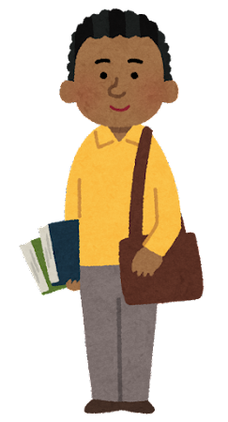

Name: Henry
Country: Kenya
get up | 6:15am
eat breakfast | 6:45am
go to school | 7:50am
study English | 9:30am
eat lunch | 12:25pm
go home | 2:30pm
do your homework | 3:20pm
eat dinner | 6:30pm
take a bath | 8:05pm
go to bed | 8:40pm

A: Hello. What’s your name? B: Hello, I’m _____________. And you?
A: Nice to meet you. Where are you from? B: I’m from _________. How about you?
A: I’m from __________.

A: What time do you ~~? B: I ~~ at ________am/pm.
My Daily Routine
Name  Country | _____________  _____________ | _____________  _____________ | _____________  _____________ | _____________  _____________
get up
eat breakfast
go to school
study English
eat lunch
go home
do your homework
eat dinner
take a bath
go to bed

Name: Sarah
Country: Singapore
get up | 6:45am
eat breakfast | 7:05am
go to school | 8:10am
study English | 11:35am
eat lunch | 12:50pm
go home | 3:40pm
do your homework | 4:55pm
eat dinner | 7:15pm
take a bath | 8:00pm
go to bed | 8:35pm

A: Hello. What’s your name? B: Hello, I’m _____________. And you?
A: Nice to meet you. Where are you from? B: I’m from _________. How about you?
A: I’m from __________.

A: What time do you ~~? B: I ~~ at ________am/pm.
My Daily Routine
Name  Country | _____________  _____________ | _____________  _____________ | _____________  _____________ | _____________  _____________
get up
eat breakfast
go to school
study English
eat lunch
go home
do your homework
eat dinner
take a bath
go to bed
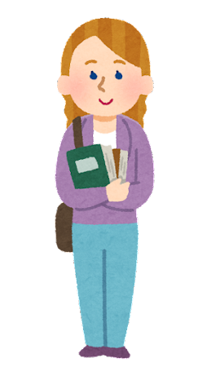

Name: Jessica
Country: New Zealand
get up | 6:30 am
eat breakfast | 7:00 am
go to school | 8:10am
study English | 10:45am
eat lunch | 1:15pm
go home | 2:50pm
do your homework | 3:35pm
eat dinner | 6:00pm
take a bath | 8:55pm
go to bed | 9:20pm

A: Hello. What’s your name? B: Hello, I’m _____________. And you?
A: Nice to meet you. Where are you from? B: I’m from _________. How about you?
A: I’m from __________.

A: What time do you ~~? B: I ~~ at ________am/pm.

