

**Learning Literature** (pp. 122-3)  
**(Task 2&3)**

Connect the dots!

Name: __________________ Class: ___

* ・　 ・ ・
* ・　 ・ ・

起 = **Beginning** 承 = **Rising|Action** 転 = **Climax** 結 = **Ending**

Characters:   
🡪 Kitty = 子猫   
🡪 Pitbull = ピットブル



ビデオを見て順番を書こう！

MOVIE #1 – “Kitbull”

( ) The kitty was playing with a bottle cap*.

( ) The kitty met* a pitbull for the first time.

(5) The kitty and pitbull slept* together. They became* best friends.

( ) It was raining outside, and the dog looked* cold.

( ) The kitty and pitbull are living with a happy family.

(3) The kitty was in trouble and the pitbull tried to help.

( ) The next morning, they ran away*.

( ) The kitty was hungry, and a man gave* some food.

ran away = 逃げ出した looked = ～そうに見えた bottle cap = ボトルキャップ

give = ～を与える，渡す，もたらす gave = 「give」の過去形 slept = 寝た

become = ～になる became = 「become」の過去形 trouble = 困難，面倒，迷惑

met = ～に会った

CHALLENGE  
Find and circle the past tense verbs!  
(上の文章で過去形の動詞を見つけて丸をつけてみよう！)



Characters:   
🡪 Bao = バオ Bao’s Girlfriend = バオの彼女  
🡪 Mom = お母さん   
🡪 Dad = お父さん

MOVIE #2 – “Bao”

TRUE OR FALSE?

( ) The mom ate a xiao long bao* and was sad.

( ) Bao played tennis in the park.

( ) The mom cooked a lot of food, but Bao did not eat it.

( ) Bao brought* his girlfriend* home, and the mom was happy.

( ) The mom ate Bao.

( ) Bao is good at making xiao long bao.

xiao long bao = ショウロンポウ brought = 「bring」の過去形 girlfriend = ガールフレンド・彼女

Sort the scenes below into the 4 categories!  
(下のシーンを「Beginning」、「Rising Action」、「Climax」、「Ending」に分類してください。)

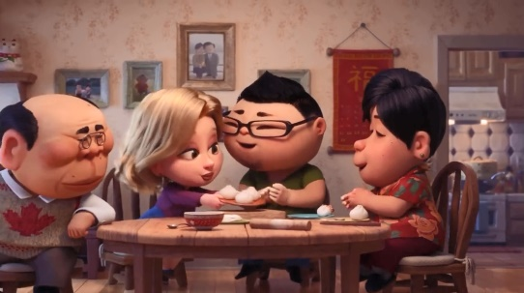

**||||||||||||||||||||||||||||||**

**|||||Rising|Action|||||**

**||||||||||||||||||||||||||||||**

**||||||||||||||||||||||||||||||**

**||||||||||||||||||||||||||||||**

**||||||||||||||||||||||||||||||**

Q&A: What’s the moral of the story?(このビデオの教訓は何でしょう。日本語OK!)  
**|||||||||||||||||||||||||||||||||||||||||||||||||||||||||||||||||||||||||||||||||||||||||||||||||**