Name: _______________ Class: ______ Number: ____ Date: ___/___
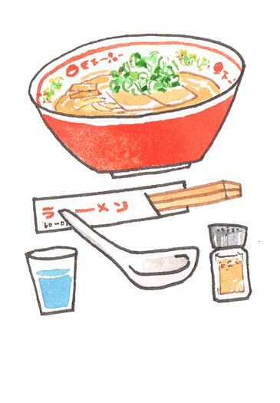
DO YOU KNOW THEM?
- ________________________________________________
________________________________________________
________________________________________________





