I got my driver’s license ________ _________
Just like we always talked about
‘Cause you were so excited for me
To finally drive up to your ______________
But today I drove through the suburbs
Crying ’cause you weren’t around

You’re probably with that blonde girl
Who always made me doubt
She’s so much ____________ than me
She’s everything I’m insecure about
Yeah, today I drove through the suburbs
‘Cause how could I ever _________ someone else?

And I know we weren’t perfect but _____ never felt this way for no one
And I just can’t imagine how you could be so ________ now that I’m gone
Guess you didn’t mean what you wrote in that song about me
‘Cause you said forever, now I drive alone past your street

And all my friends are ____________
Of hearing how much I miss you, but
I kinda feel sorry for them
‘Cause they’ll never know you the way that I do, yeah
Today I drove through the suburbs
And pictured I was _____________ home to you

And I _______________ we weren’t perfect
But I’ve never felt this way for no one, oh
And I just can’t imagine how you could be so okay, now that I’m gone
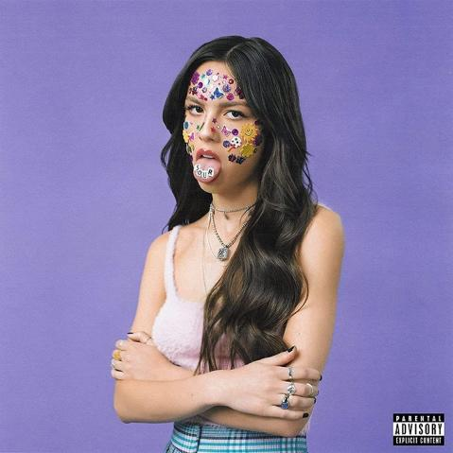
I guess you didn’t mean what you wrote in that ___________ about me
‘Cause you said forever, now I drive alone past your street

Red lights, stop signs
I still see your face in the white cars, front yards
Can’t drive past the places we used to go to
‘Cause you know I still love _________, babe (ooh, ooh, ooh, ooh)
Sidewalks we crossed
I still hear your voice in the traffic, we’re laughing
Over all the noise
God, I’m so blue, know we’re through
But you know I still love you, babe (ooh, ooh, ooh, ooh)

I know we weren’t ___________ but I’ve _____________ felt this way for no one
And I just can’t imagine how you could be so okay, now that I’m gone
‘Cause you didn’t mean what you wrote in that song about me
‘Cause you said forever, now I drive alone past your street
Yeah, you said forever, now I drive alone past your street

