Read the situations of the people below and react to them by using any of the following expressions “I’m sure…I’m glad (happy)….I’m surprised…I’m sorry (sad) etc

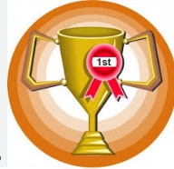
１.Your friend’s team won the first prize at the Fukuoka prefectural tournament . He/she is very excited.

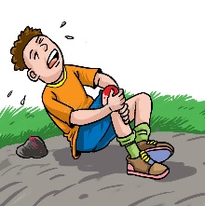
2. Jun injured his knee during the P.E class. He will be in the hospital for 3 months. He is worried a lot and crying all day and night long.

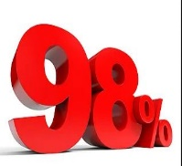
3. Nanami scored over 98% on all her tests .Her mother will give her JPY 100,000 as a gift.

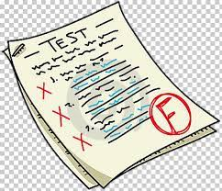
4. I failed a very important test. I don’t know what to do .I can’t eat any food.

Name: ____________________ Class_________

