Hi, how are you?

I’m fine, thanks, and you?

I’m good, thanks.

I love quiz games!

Me too! Me too! Let’s play!

Four hints. One, its an animal. Two, its brown. Three, it can eat bananas, It can climb a tree

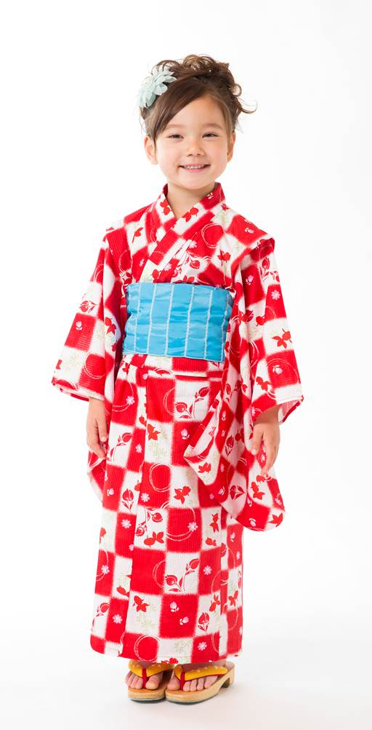
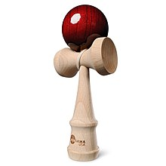
Hmmmm. Is it a monkey?

Yes, you got it. Your turn.

Ok. One, its an object. Two, its heavy. Three, it’s square, Four, I can watch itteQ.

Hmmmm, it is a…

