School Voting

What do you want to change about your school?
Please circle your choice and explain your answer!

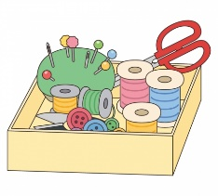
Example:
I want more (home economics) (engineering) classes.

I want more home economics classes because I like learning______ about cooking and sewing. ______________________________________________
____________________________________________________________________________________________________________________
- I want students to (wear uniforms) (not wear uniforms).

- I want (English) (other language) classes.

____________________________________________________________________________________________________________________________________________________________________________________________________________________________________________________________________________________________________________________________________________________________
- I want to eat lunch in (the classroom) (a cafeteria).

- What do you want at your school? Please write your idea!

