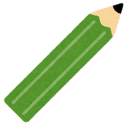  pencil | 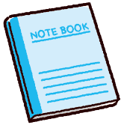  notebook | 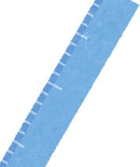  ruler | eraser | 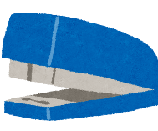  stapler
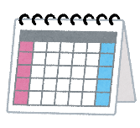  calendar | highlighter | magnet | 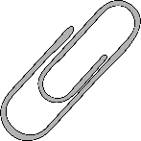  paperclip | 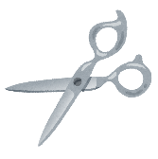  scissors
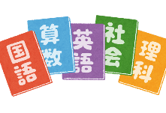  textbooks | 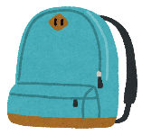  backpack | FREE | 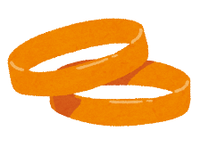  rubber band | glue stick
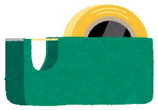  tape | pencil case | 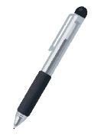  pen | correction tape | sticky notes
bookmark | 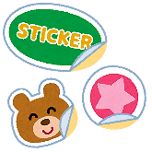  stickers | marker | 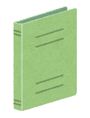  file folder | 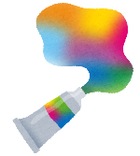  paint

eraser | correction tape | glue stick | calendar | backpack
marker | pencil | stickers | bookmark | ruler
pencil case | stapler | FREE | notebook | scissors
magnet | paint | tape | file folder | pen
sticky notes | highlighter | paperclip | rubber band | textbooks

textbooks | magnet | calendar | stickers | marker
pencil | glue stick | pencil case | notebook | correction tape
ruler | file folder | FREE | tape | highlighter
paint | scissors | bookmark | sticky notes | pencil case
pen | eraser | stapler | backpack | rubber band

backpack | stapler | marker | bookmark | tape
highlighter | notebook | correction tape | scissors | pencil
paperclip | textbooks | FREE | rubber band | paint
sticky notes | stickers | pencil case | magnet | pen
glue stick | calendar | file folder | ruler | eraser

stickers | pencil | paperclip | scissors | file folder
highlighter | calendar | stapler | eraser | magnet
glue stick | ruler | FREE | backpack | rubber band
notebook | marker | sticky notes | pen | bookmark
correction tape | tape | paint | textbooks | pencil case

rubber band | tape | textbooks | marker | ruler
scissors | file folder | paint | stickers | correction tape
eraser | glue stick | FREE | pencil | pencil case
stapler | sticky notes | calendar | bookmark | backpack
pen | paperclip | notebook | highlighter | magnet

magnet | rubber band | sticky notes | pen | highlighter
paperclip | bookmark | textbooks | pencil case | stickers
backpack | ruler | FREE | notebook | pencil
scissors | correction tape | file folder | glue stick | calendar
paint | marker | eraser | stapler | tape

glue stick | sticky notes | rubber band | paint | bookmark
stickers | marker | tape | calendar | highlighter
file folder | correction tape | FREE | textbooks | paperclip
ruler | pen | backpack | magnet | eraser
pencil case | pencil | scissors | notebook | stapler

