**Passive Form - Writing Practice**

**are/were**

**by**

**in**

**is/was**

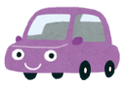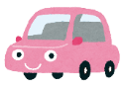

**made**

1. ______________________________________________________



**eaten**

1. ______________________________________________________



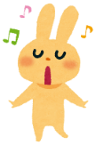

songs

**sung**

1. _____________________________________________________





**seen**

1. ______________________________________________________



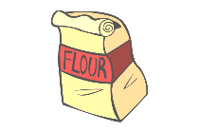

**used**

1. ______________________________________________________

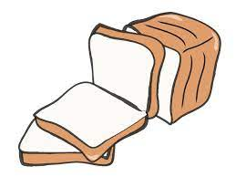

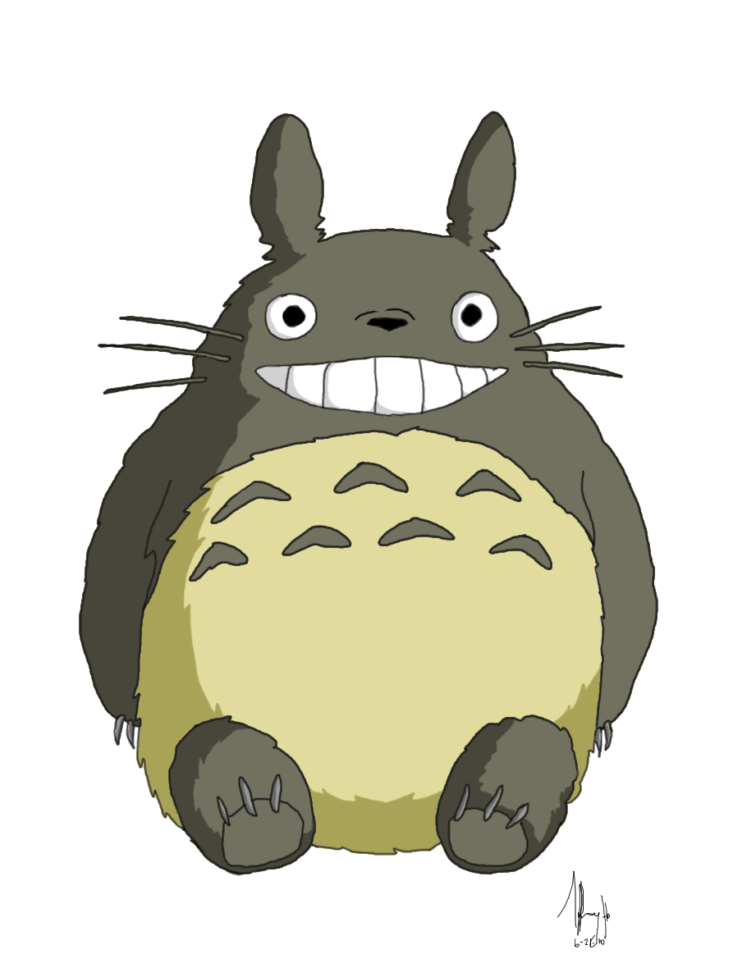

**made**

1. 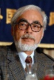______________________________________________________

[This Photo](http://dragonphoenixdemon.deviantart.com/art/totoro-174902243) by Unknown Author is licensed under [CC BY-NC](https://creativecommons.org/licenses/by-nc/3.0/)