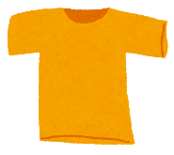  T-shirt | 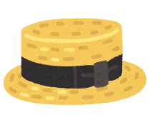  hat | 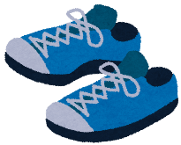  shoes | 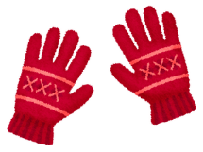  gloves | 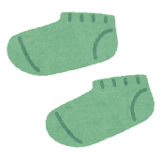  socks
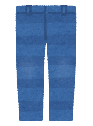  jeans | 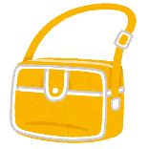  bag | 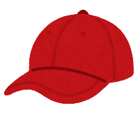  cap | 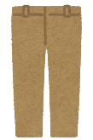  pants | 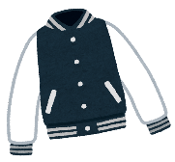  jacket
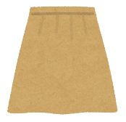  skirt | 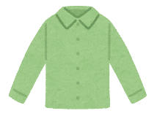  blouse | FREE | 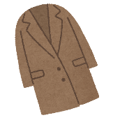  coat | 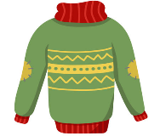  sweater
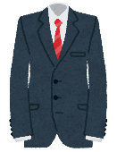  suit | 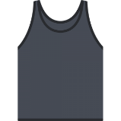  tank top | 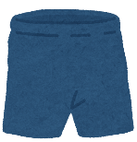  shorts | 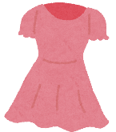  dress | 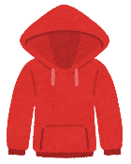  hoodie
tie | 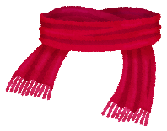  scarf | 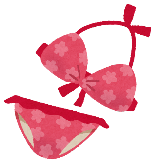  swimsuit | 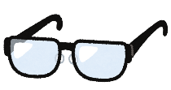  glasses | 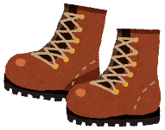  boots

shorts | skirt | suit | tank top | swimsuit
bag | hat | sweater | jeans | shoes
tie | jacket | FREE | hoodie | pants
blouse | boots | T-shirt | gloves | cap
socks | glasses | coat | scarf | dress

jacket | swimsuit | boots | coat | cap
scarf | tie | T-shirt | tank top | pants
glasses | shorts | FREE | jeans | hat
gloves | blouse | shoes | dress | skirt
hoodie | sweater | socks | bag | suit

tie | suit | T-shirt | glasses | shoes
gloves | scarf | dress | bag | socks
coat | hoodie | FREE | skirt | boots
jeans | swimsuit | hat | cap | jacket
blouse | shorts | pants | tank top | sweater

hoodie | bag | shorts | blouse | swimsuit
sweater | glasses | tie | skirt | shoes
hat | boots | FREE | gloves | scarf
jacket | socks | coat | suit | dress
tank top | T-shirt | jeans | cap | pants

sweater | skirt | jeans | dress | glasses
tie | shorts | hoodie | bag | suit
scarf | socks | FREE | pants | blouse
boots | cap | swimsuit | shoes | T-shirt
coat | tank top | hat | jacket | gloves

cap | dress | scarf | hat | tie
suit | boots | swimsuit | jacket | glasses
T-shirt | coat | FREE | socks | tank top
bag | sweater | pants | skirt | jeans
shoes | gloves | blouse | hoodie | shorts

socks | tank top | pants | blouse | coat
cap | dress | jacket | sweater | hoodie
boots | swimsuit | FREE | T-shirt | scarf
shorts | tie | bag | gloves | shoes
jeans | skirt | hat | suit | glasses

