Hi, how are you?

I’m fine, thanks, and you?

I’m good, thanks.

What sport do you like?

I like tennis. It is fun. What food do you like?

I like pizza. It is delicious. What time do you get up?

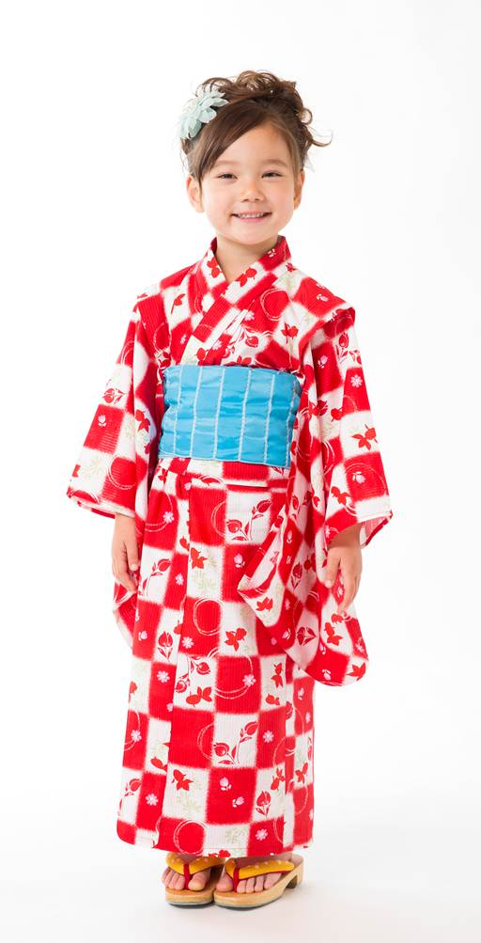
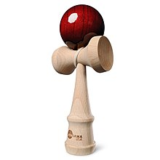
I get up at 6:30. What time do you go to bed?

I go to bed at 10:00. How many pens do you have?

I have five pens. When is your birthday?

My birthday is August 5th.

