Which is brighter, the Moon or the Sun?
The ______ is brighter than the _________.

Which is brighter, a candle or fireworks?
____________ are _____________er than a ___________.

Which is longer, the news or a movie?
A ___________ is ___________ than the _____________.

Which is longer, a soccer field or a marathon?
A ________________ is ____________ __________ a ____________ __________

Which is taller, Tokyo Tower or Tokyo Sky Tree?
__________ ______ ________ is ____________ than __________ ___________.

Which is faster, a turtle or a rabbit?
A ____________ ____ ____________ ________ a ____________.

Which is faster, a bicycle or a car?
_________________________________________________________________.

Which is hotter, an onsen or a fire?
_________________________________________________________________.

Which is warmer, Hawaii or Hokkaido?
_________________________________________________________________.

Which is cuter, a spider or a panda?
_________________________________________________________________.

Which is harder, an orange or a baseball?
_________________________________________________________________.

Which is colder, ice or water?
_________________________________________________________________.

Which is quieter, an ant or a bee?
_________________________________________________________________.
Which can fly higher, a bird or a spaceship?
____________________________ can fly higher ___________________________________.

Which can run faster, a monkey or a horse?
____________________________________________________________________________.

Which cat is the biggest? Which cat is the thinnest?
A B C A B C

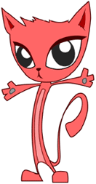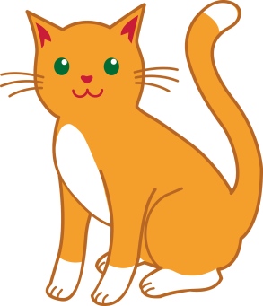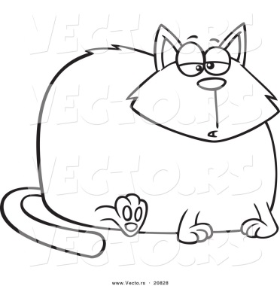
C
B
A

Who is the heaviest? Who is the lightest?
A B C A B C
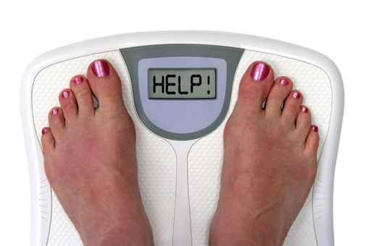
C
B
A
50
40
30

There are 3 people: A, B, and C.
One person weighs 30kg, one person weighs 40kg, and One person weighs 50kg.
Person C is heavier than person A.
Person B is heavier than person C.
How much does A weigh? How much does B weigh? How much does C weigh?
A
B
C

