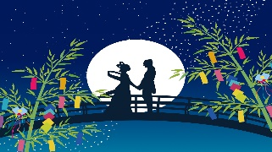
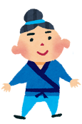
Name: ______________ Class: ____ Number: ____
- What do you want to do this summer?
_________________________________________________________
_________________________________________________________
_________________________________________________________
- What do you like to do in your free time?
_________________________________________________________
_________________________________________________________
_________________________________________________________
- What do visitors like to do in Uonuma?
_________________________________________________________
_________________________________________________________
_________________________________________________________
- Where do you want to go? What do you want to do there?
_________________________________________________________
_________________________________________________________
_________________________________________________________
- Who is your friend? What does your friend like to do?
_________________________________________________________
_________________________________________________________
_________________________________________________________

