Match the verbs.

V-ing (すること)

**travel -> _____________________________**

**cook -> _____________________________**

**study -> _____________________________**

**run -> _____________________________**

**watch -> _____________________________**

**use -> _____________________________**

**swim -> _____________________________**

**make -> _____________________________**

**meet -> _____________________________**

**sleep -> _____________________________**

**find -> _____________________________**

泳ぐ

見つける

走る

勉強する

寝る

見る

料理する

会う

旅行する

使う

作る

**トイレを使うこと　―＞ _____________________________________________________________**

**海で泳ぐこと　―＞ __________________________________________________________________**

**友達を作る　―＞ _____________________________________________________________________**

**pirate 海賊　かいぞく**

**treasure　宝物　たからもの**

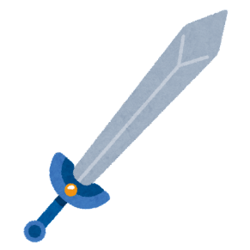**sword　剣　けん**

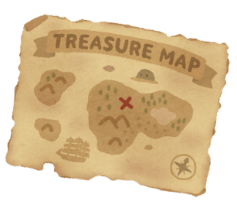**map　地図　ちず**

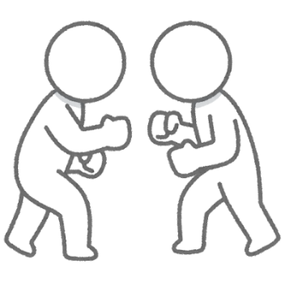**battle　戦闘・戦い**