Do you like playing the piano?
.
Do you like…?
Yes, I do. I like… / No I don’t. I don’t like…
Round 1 – Bingo!
playing basketball  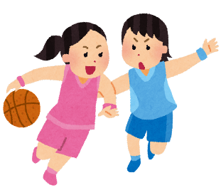  Sign:  _____________ | reading books  Sign:  ____________ | 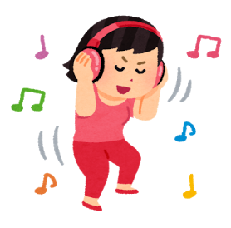  listening to music  Sign:  _____________
drawing pictures  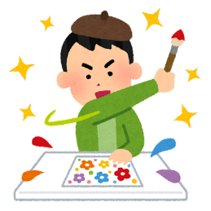  Sign:  _____________ | watching TV  Sign:  _____________ | going shopping  Sign:  _____________
eating natto  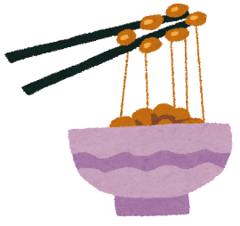  Sign:  _____________ | singing karaoke  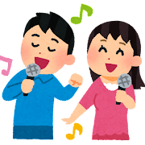  Sign:  _____________ | studying English  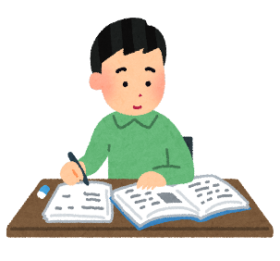  Sign:  _____________

Round 2 – Write about your friends:
例)_________________________________________________________________________________
Tom likes singing karaoke.
- _________________________________________________________________________________
- _________________________________________________________________________________
- ________________________________________________________________________________

Round 3 – Word Search!
dancing drawing pictures eating natto
going shopping playing basketball reading books
recycling reducing reusing
running singing karaoke taking pictures
watching TV

