Name: ________ Class Number Program 4-1, “What do you”
Part 1: Let’s talk!
on | Sunday Monday Tuesday Wednesday Thursday Friday Saturday  曜日＋ (morning/afternoon/evening)?
1. Q質問: What do you usually do on Sunday afternoon?
A答え: I usually [watch TV / play soccer / など].

in | the ( summer / fall / winter / spring )?  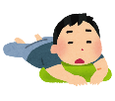  your free time?
2. Q質問: What do you usually do in the summer?
A答え: I usually [go to the beach / eat watermelon / など].

for | 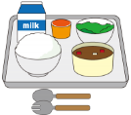  ( breakfast / lunch / dinner )?
3. Q質問: What do you usually have for dinner?
A答え: I usually [have spaghetti / have curry / など].

A (答え) Idea Box
play [ baseball / tennis / soccer / basketball]
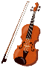
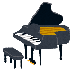
play [ the piano / the guitar / the violin]
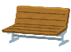
go to [ the beach / Tenjin / the park]
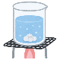
study [ math / science / social studies / English]
have [ rice / a hamburger / bread] など!

Part 2: Let’s write!
1. “on”
Q: What do you usually do on
A: I usually

2. “in”
Q: What do you usually do in
A: I usually

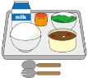
3. “for”
Q: What do you usually have for
A: I usually

