Classroom Olympics

Name:

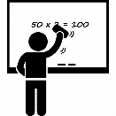

Who is faster?

Example: Mimu than Tom.

is faster



Who can keep their eyes open longer?

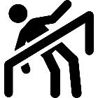

Who can go lower?

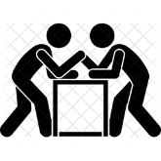

Who is stronger?



Who is luckier?

X 10

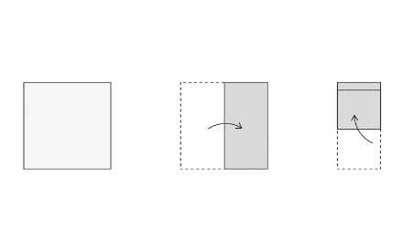Who can fold this paper smaller?