Do you like playing the piano?
.
Do you like…?
Yes, I do. ______________ is ________.
No, I don’t. ______________ is ________.

Round 1 – Bingo!
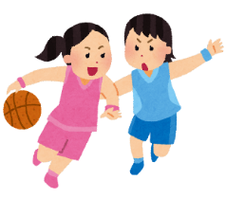  Playing basketball is _____________  Sign:  _____________ | Reading books is _____________  Sign:  ____________ | 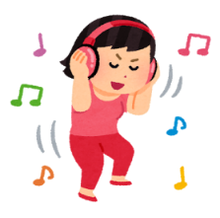  Listening to music is _______________  Sign:  _____________
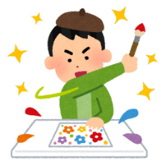  Drawing pictures is _______________  Sign:  _____________ | Watching TV is _____________  Sign:  _____________ | Going shopping is ______________  Sign:  _____________
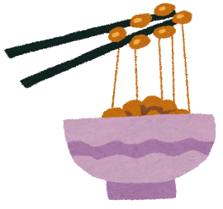  Eating natto is ______________  Sign:  _____________  Sign:  _____________  Sign:  _____________ | 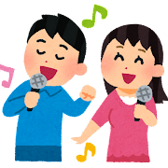  Singing karaoke is _______________ | 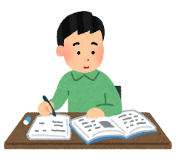  Studying English is _____________
Round 2 – Write down your friends comments:
例)Name: _____________ Comment: _________________________________________________
Singing karaoke is fun.
Tom
- Name: _____________ Comment: _________________________________________________
- Name: _____________ Comment: _________________________________________________
- Name: _____________ Comment: _________________________________________________

