**BINGO: DATES**

＿_年＿組_＿番

**My name is:**

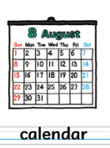

BINGO SHEET

|  |  |  |
| --- | --- | --- |
|  |  |  |
|  |  |  |
|  |  |  |

|  |  |  |  |  |
| --- | --- | --- | --- | --- |
| 1st | 2nd | 3rd | 4th | 5th |
| 6th | 7th | 8th | 9th | 10th |
| OK | 11th | 12th | 13th | 14th |
| 15th | 16th | Hi | 17th | 18th |
| 19th | 20th | 21st | 21st | 22nd |
| 23rd | 24th | 25th | 26th | 27th |
| 28th | 29th | 30th | 31st |



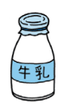



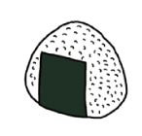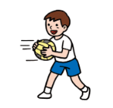

Callers Card

You can just mark these off or cut them up and put them in a bingo bag.

|  |  |  |  |  |
| --- | --- | --- | --- | --- |
| **1st** | **2nd** | **3rd** | **4th** | **5th** |
| **6th** | **7th** | **8th** | **9th** | **10th** |
| **OK** | **11th** | **12th** | **13th** | **14th** |
| **15th** | **16th** | **Hi** | **17th** | **18th** |
| **19th** | **20th** | **21st** | **21st** | **22nd** |
| **23rd** | **24th** | **25th** | **26th** | **27th** |
| **28th** | **29th** | **30th** | **31st** |