

乗り換え？

**Asking and Giving Directions: Map**(p. 81)

|  |  |  |  |  |
| --- | --- | --- | --- | --- |
| **DICE** | **CURRENT LOCATION** (現在地) | **DESTINATION** (行き先) | **CHANGE TRAINS?** | **COST** |
| [例] | **Mario** Station | USJ Universal Studios Logo Download Vector | No | 210 yen |
|  | **Anpanman** Station |  | No | 190 yen |
|  | **Kirakira** Station |  | No | 530 yen |
|  | **Pizza** Station |  | Yes | 340 yen |
|  | **Hashimoto** Station |  | No | 450 yen |
|  | **Hotdog** Station | USJ Universal Studios Logo Download Vector | Yes | 220 yen |
|  | **Pikachu** Station |  | No | 670 yen |

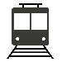

❤ = **Heart** Line  
▲ = **Triangle** Line

★ = **Star** Line  
◆ = **Diamond** Line

Train Lines

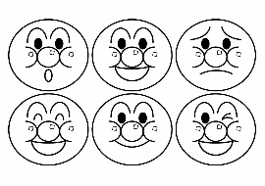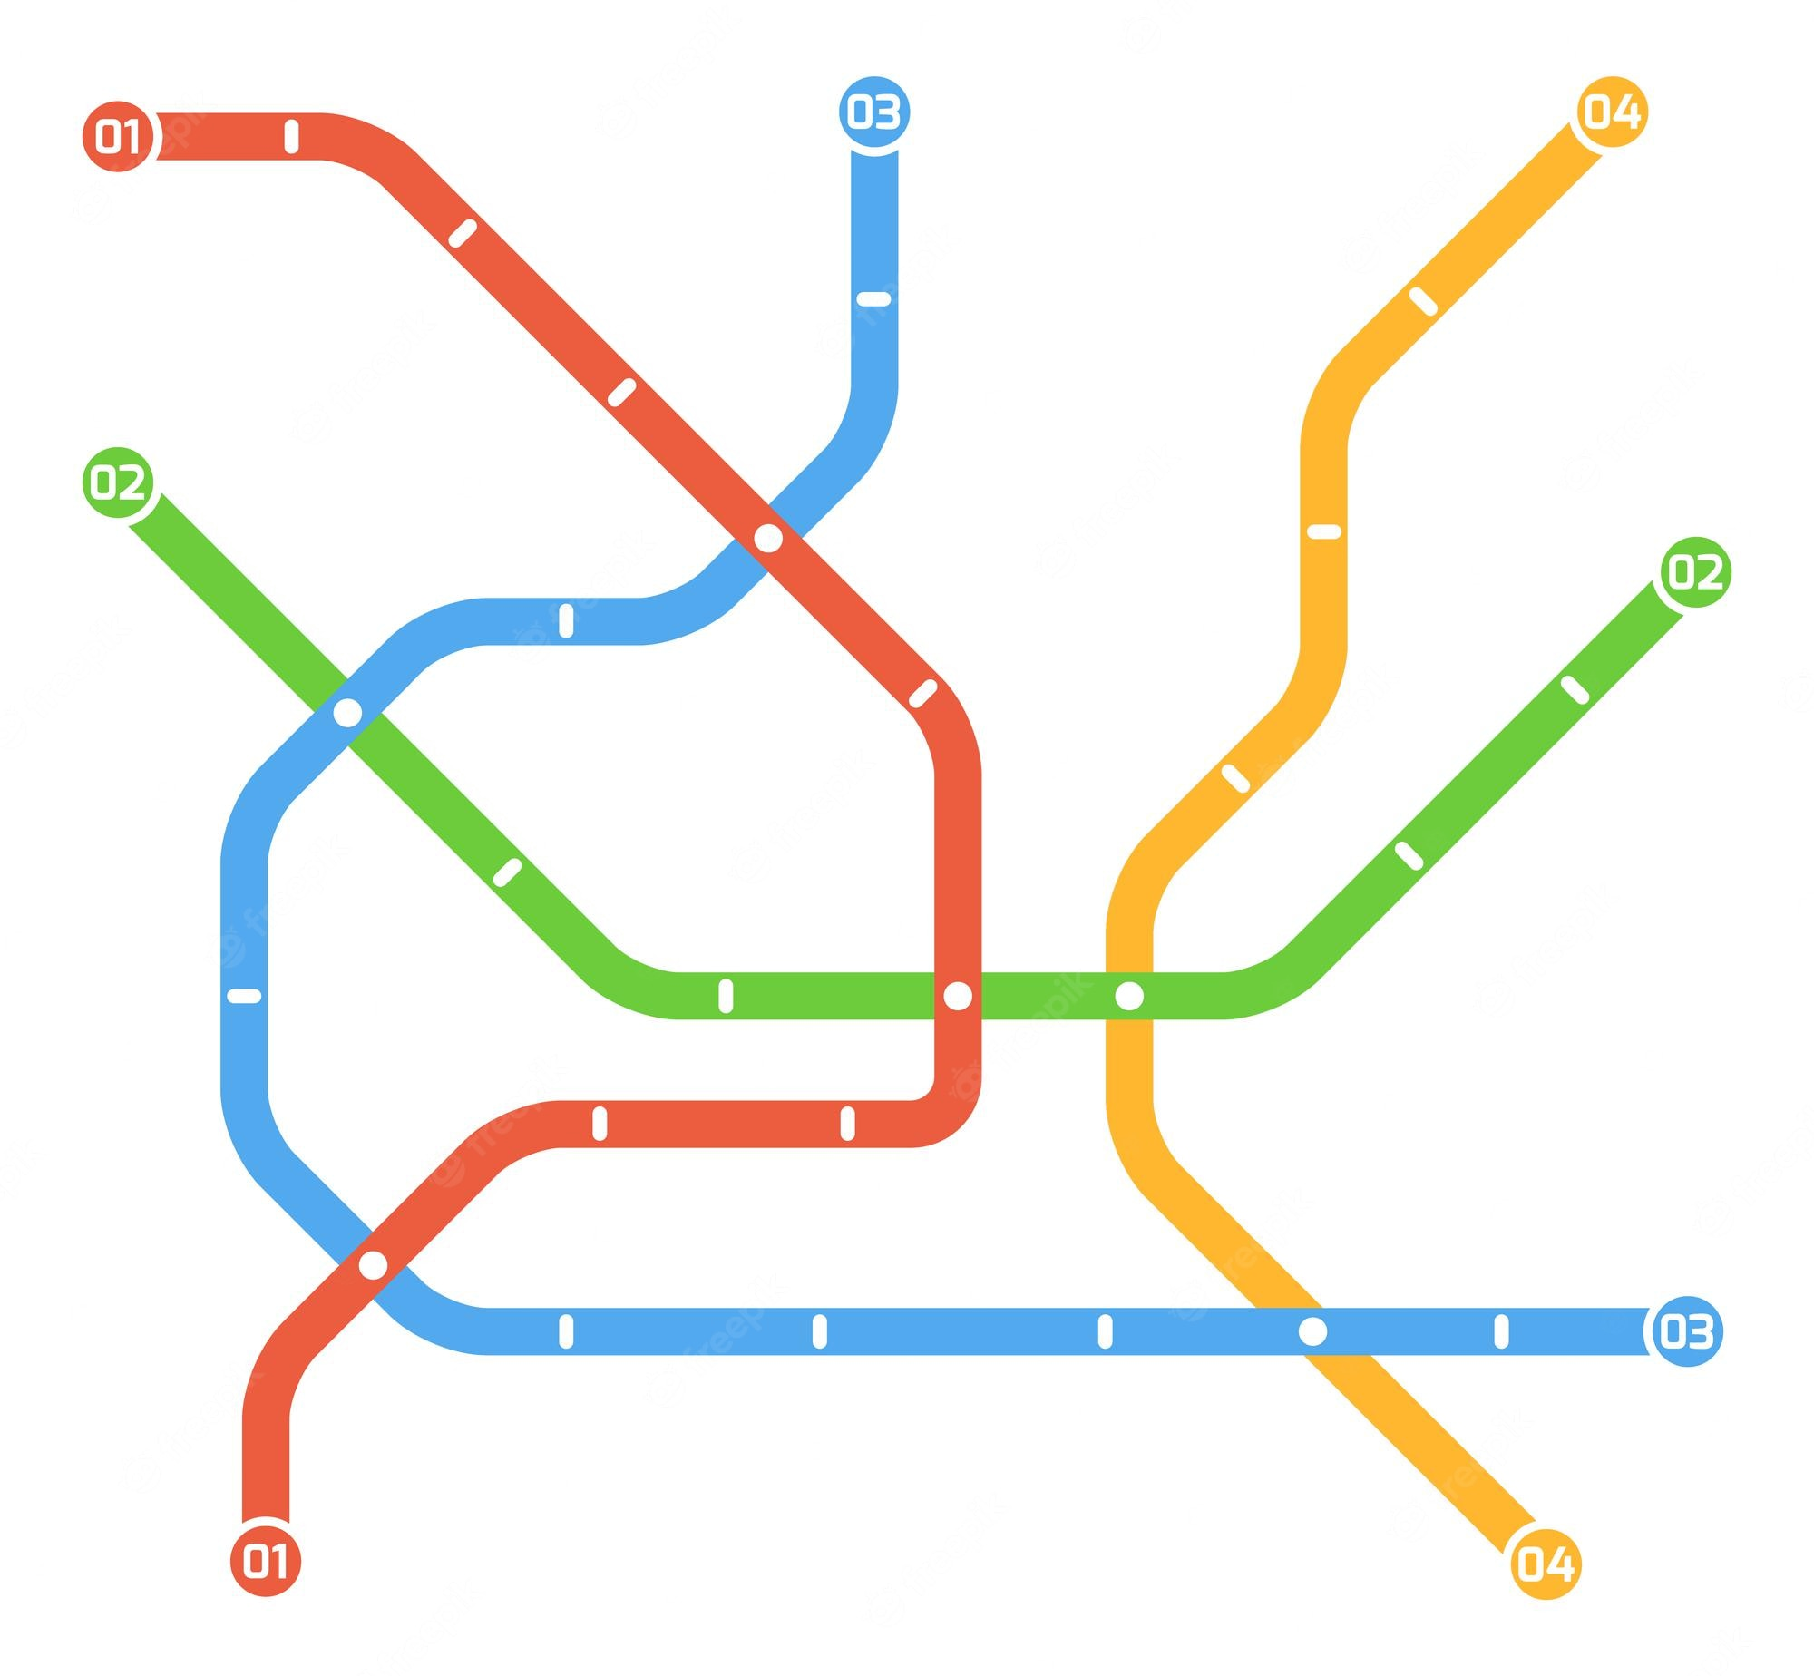

**❤**

**★**

**▲**

**Mario  
Station**

**Kirakira  
Station**

**Pizza  
Station**

**Pikachu  
Station**

**Anpanman  
Station**

**Tokyo Skytree**

**Hotdog  
Station**

**Disneyland**

**Hashimoto  
Station**

**Kanto 2nd** JHS

**Mt. Fuji**

**Iwaki City  
Hospital**

**Iwaki  
Station**

**USJ**

**[例]**

**◆**

**◆**

**❤**

**★**

**▲**