Description: C:\Documents and Settings\t27\Local Settings\Temporary Internet Files\Content.IE5\69AN8HUT\MC900241151[1].wmf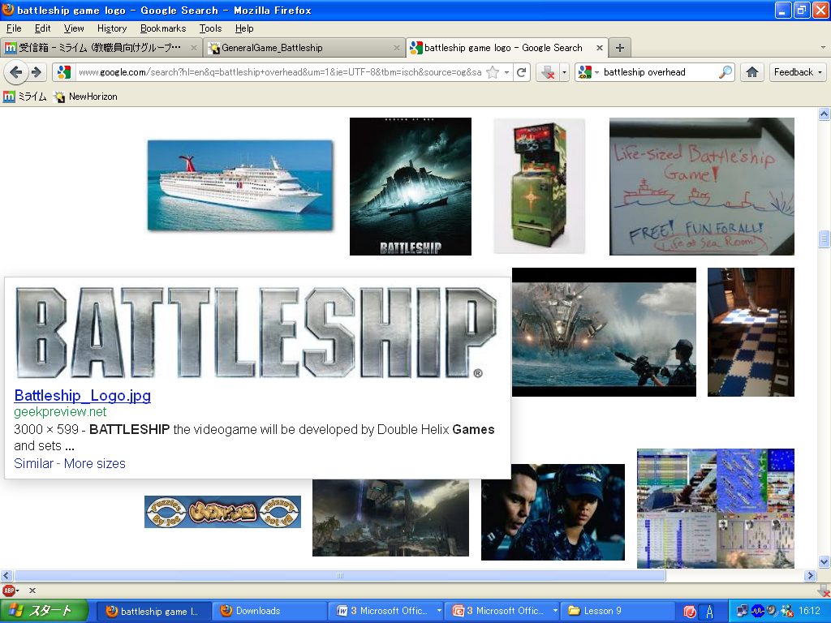Description: C:\Documents and Settings\t27\Local Settings\Temporary Internet Files\Content.IE5\69AN8HUT\MC900241151[1].wmfMy name is _____________________________________.

I’m in class _____, no. _____.

**Can you ~?** **HIT (O)** = Yes, I can. **MISS (X)** = No, I can’t.

|  |  |  |  |  |  |
| --- | --- | --- | --- | --- | --- |
| Can you play… | [http://tse1.mm.bing.net/th?&id=OIP.M6bb20666ce944e9e6058e29dc1cc6a52o0&w=300&h=278&c=0&pid=1.9&rs=0&p=0](http://www.bing.com/images/search?q=soccer+clip+art&view=detailv2&&id=1F469009B6CE585420207CF3B0A759F77F218455&selectedIndex=4&ccid=a7IGZs6U&simid=608045710730986321&thid=OIP.M6bb20666ce944e9e6058e29dc1cc6a52o0)  soccer? | [http://tse1.mm.bing.net/th?&id=OIP.Mabcb9545a1179eeda00ba649c0ede983o0&w=139&h=161&c=0&pid=1.9&rs=0&p=0](http://www.bing.com/images/search?q=volleyball+clip+art&view=detailv2&&id=9549B39FEC3262DD95D74EF58C29DDE51A449356&selectedIndex=30&ccid=q8uVRaEX&simid=608049795241414159&thid=OIP.Mabcb9545a1179eeda00ba649c0ede983o0)volleyball? | [http://tse1.mm.bing.net/th?&id=OIP.M63744a5202d49b9c98c33c4626c66754o0&w=146&h=154&c=0&pid=1.9&rs=0&p=0](http://www.bing.com/images/search?q=tennis+clip+art&view=detailv2&&id=D8AF9E1694983F5625EF79F75561C2A268E7D928&selectedIndex=7&ccid=Y3RKUgLU&simid=608052896214093223&thid=OIP.M63744a5202d49b9c98c33c4626c66754o0)  tennis? | [http://tse1.mm.bing.net/th?&id=OIP.M18626265e290374252017ffd020ca631o0&w=227&h=196&c=0&pid=1.9&rs=0&p=0](http://www.bing.com/images/search?q=baseball+clip+art&view=detailv2&&id=13EC3879559A0E88FB1C902E330EEF466D24D7B0&selectedIndex=15&ccid=GGJiZeKQ&simid=608020782743618204&thid=OIP.M18626265e290374252017ffd020ca631o0)baseball? | [http://tse1.mm.bing.net/th?&id=OIP.M23e3cd436ce1b91bf4fc2a5f71ee6b56H0&w=207&h=231&c=0&pid=1.9&rs=0&p=0](http://www.bing.com/images/search?q=basketball+clip+art&view=detailv2&&id=61A82BCAFC87F9D748097A8EA2DF66A2BDD78ED1&selectedIndex=9&ccid=I%2bPNQ2zh&simid=608041583259813367&thid=OIP.M23e3cd436ce1b91bf4fc2a5f71ee6b56H0)basketball? |
| Can you speak… | Spanish?  ¡Hola! | English?  Hello! | Japanese?  こんにちは！ | French?  Bonjour! | German?  Hallo! |
| Can you ride… | C:\Users\mouse\AppData\Local\Microsoft\Windows\Temporary Internet Files\Content.IE5\7ZAAEY4C\MC900197730[1].wmfa bike? | [http://tse1.mm.bing.net/th?&id=OIP.Mb8cd5b477e4f32ea2658fc2c1dc8ffd5o0&w=157&h=230&c=0&pid=1.9&rs=0&p=0](http://www.bing.com/images/search?q=unicycle+clip+art&view=detailv2&&id=88A85E46D7549FDF8907AAF19DEC85D28E39B29A&selectedIndex=27&ccid=uM1bR35P&simid=607988175341225741&thid=OIP.Mb8cd5b477e4f32ea2658fc2c1dc8ffd5o0)  a unicycle? | [http://tse1.mm.bing.net/th?&id=OIP.M5451a55303b4b8b52bdc66133ac32ca3o0&w=300&h=251&c=0&pid=1.9&rs=0&p=0](http://www.bing.com/images/search?q=horse+riding+clip+art&view=detailv2&&id=F0E37A7AF25E047B3070270EEC8B29FC7E454492&selectedIndex=7&ccid=VFGlUwO0&simid=608000531969803705&thid=OIP.M5451a55303b4b8b52bdc66133ac32ca3o0)  a horse? | [http://tse1.mm.bing.net/th?&id=OIP.M4abbf0aa4e4ca50addcc0970047e60e4H0&w=300&h=262&c=0&pid=1.9&rs=0&p=0](http://www.bing.com/images/search?q=skateboard+clip+art&view=detailv2&&id=0CC4AF64D606026F15B28421E9C958718024EB43&selectedIndex=169&ccid=Srvwqk5M&simid=608045392902425114&thid=OIP.M4abbf0aa4e4ca50addcc0970047e60e4H0)  a skateboard? | [http://tse1.mm.bing.net/th?&id=OIP.M2f481c7a90aec0334f6d0564df4460f4o0&w=225&h=237&c=0&pid=1.9&rs=0&p=0](http://www.bing.com/images/search?q=scooter+clip+art&view=detailv2&&id=52EE247D0577A9BD094EC6233DF4FAED51A46734&selectedIndex=27&ccid=L0gcepCu&simid=608051277007883805&thid=OIP.M2f481c7a90aec0334f6d0564df4460f4o0)  a scooter? |
| Can you play… | [http://tse1.mm.bing.net/th?&id=OIP.M2b5f8a02b28b6b9c87d55834ba009261H0&w=249&h=196&c=0&pid=1.9&rs=0&p=0](http://www.bing.com/images/search?q=violinclip+art&view=detailv2&&id=B21257F5B83D88459C8065CE862525DA1204D436&selectedIndex=0&ccid=K1%2bKArKL&simid=608030704118795907&thid=OIP.M2b5f8a02b28b6b9c87d55834ba009261H0)  the violin? | [http://tse1.mm.bing.net/th?&id=OIP.M05d511ba6f4ccd9df7023c7c07947f36o0&w=300&h=193&c=0&pid=1.9&rs=0&p=0](http://www.bing.com/images/search?q=trumpet+clip+art&view=detailv2&&id=A6B2EAB76A45BC54B9830710297CB8C7D194DA20&selectedIndex=2&ccid=BdURum9M&simid=608021229424610686&thid=OIP.M05d511ba6f4ccd9df7023c7c07947f36o0)  the trumpet? | C:\Users\mouse\AppData\Local\Microsoft\Windows\Temporary Internet Files\Content.IE5\UERTV70V\MC900441302[1].pngthe guitar? | [http://tse1.mm.bing.net/th?&id=OIP.M94b7d58922baeba452d051cc66858700H0&w=231&h=209&c=0&pid=1.9&rs=0&p=0](http://www.bing.com/images/search?q=flute+clip+art&view=detailv2&&id=64E747B1E82B82AD20A0477EF6B52C33BD6DE025&selectedIndex=4&ccid=lLfViSK6&simid=608010921494711594&thid=OIP.M94b7d58922baeba452d051cc66858700H0)  the flute? | [http://tse1.mm.bing.net/th?&id=OIP.Mc16b580de15e31460200258f8218cab4o0&w=268&h=240&c=0&pid=1.9&rs=0&p=0](http://www.bing.com/images/search?q=piano+clip+art&view=detailv2&&id=14437B596E2ACB916FD4C23835D6214850ADE978&selectedIndex=5&ccid=wWtYDeFe&simid=607993934908690049&thid=OIP.Mc16b580de15e31460200258f8218cab4o0)  the piano? |
| Can you use… | C:\Users\mouse\AppData\Local\Microsoft\Windows\Temporary Internet Files\Content.IE5\OBMLVMIX\MC900389724[1].wmfa computer? | [http://tse1.mm.bing.net/th?&id=OIP.M3b76dde357fdb89004f3a3894bb5eec4H0&w=300&h=166&c=0&pid=1.9&rs=0&p=0](http://www.bing.com/images/search?q=clip+art+chopsticks&view=detailv2&&id=8DD65EECC2856F03D0606EACDB680D6FDA2BC5BA&selectedIndex=2&ccid=O3bd41f9&simid=608030132892994821&thid=OIP.M3b76dde357fdb89004f3a3894bb5eec4H0)  chopsticks? | C:\Users\mouse\AppData\Local\Microsoft\Windows\Temporary Internet Files\Content.IE5\UERTV70V\MC900441332[1].pnga cell phone? | [http://tse1.mm.bing.net/th?&id=OIP.Mf5b9fa2dc1f1772ebf4d9d7943d8f9d4H0&w=300&h=300&c=0&pid=1.9&rs=0&p=0](http://www.bing.com/images/search?q=clip+art+knife&view=detailv2&&id=E485B6B703FB8AD93C2B1639E80449516C158B0B&selectedIndex=0&ccid=9bn6LcHx&simid=608033659051573783&thid=OIP.Mf5b9fa2dc1f1772ebf4d9d7943d8f9d4H0)  a knife? | [http://tse1.mm.bing.net/th?&id=OIP.M2b7c5cbcf12594c47b3f5649d2abb755o0&w=300&h=187&c=0&pid=1.9&rs=0&p=0](http://www.bing.com/images/search?q=clip+art+use+dictionary&view=detailv2&&id=0848780C1FEF5535F038ABB257052B01E990A523&selectedIndex=2&ccid=K3xcvPEl&simid=608028964658744705&thid=OIP.M2b7c5cbcf12594c47b3f5649d2abb755o0)  a dictionary? |
| Can you… | [http://tse1.mm.bing.net/th?&id=OIP.Mccdcd223bee37e1833c1ae11b0743eeao0&w=148&h=151&c=0&pid=1.9&rs=0&p=0](http://www.bing.com/images/search?q=ski+clip+art&view=detailv2&&id=CD9A6467DD12D91E8C9C6848A2EF4856503E3B5C&selectedIndex=13&ccid=zNzSI77j&simid=608022200080662763&thid=OIP.Mccdcd223bee37e1833c1ae11b0743eeao0)  ski? | [http://tse1.mm.bing.net/th?&id=OIP.Me7c438c3e0a2358e31dc2e5bf1ea9e3co0&w=226&h=151&c=0&pid=1.9&rs=0&p=0](http://www.bing.com/images/search?q=swim+clip+art&view=detailv2&&id=F3CA2F955A9C55FCD632C506A09A8ADE3FE9CB09&selectedIndex=16&ccid=58Q4w%2bCi&simid=608034260341752252&thid=OIP.Me7c438c3e0a2358e31dc2e5bf1ea9e3co0)  swim? | [http://tse1.mm.bing.net/th?&id=OIP.M59a93e0ca27532624f953e988d625002H0&w=240&h=299&c=0&pid=1.9&rs=0&p=0](http://www.bing.com/images/search?q=dance+clip+art&view=detailv2&&id=33FF0D2587BA6FB157F325D77A6C15F2D94A92D8&selectedIndex=29&ccid=Wak%2bDKJ1&simid=608023535815298656&thid=OIP.M59a93e0ca27532624f953e988d625002H0)  dance? | [http://tse1.mm.bing.net/th?&id=OIP.M2ef1a821c8ba32fece441bd5b782635fo0&w=300&h=275&c=0&pid=1.9&rs=0&p=0](http://www.bing.com/images/search?q=singing+clip+art&view=detailv2&&id=B94706F612EC3BD2BA4516D1C7C4F6985F287A5D&selectedIndex=7&ccid=LvGoIci6&simid=608018244415918036&thid=OIP.M2ef1a821c8ba32fece441bd5b782635fo0)  sing? | [http://tse1.mm.bing.net/th?&id=OIP.M03544506d38a071b343daa57ef95adb8H0&w=227&h=299&c=0&pid=1.9&rs=0&p=0](http://www.bing.com/images/search?q=whistling+clip+art&view=detailv2&&id=C09F4B26335E7396300F840959C9F226704F0C21&selectedIndex=11&ccid=A1RFBtOK&simid=608042777273108324&thid=OIP.M03544506d38a071b343daa57ef95adb8H0)  whistle? |

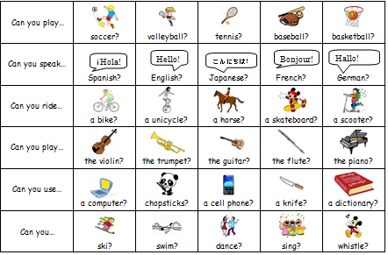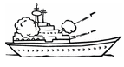

You each have FOUR ships:

|  |  |  |  |
| --- | --- | --- | --- |
|  |  |  |  |

|  |  |  |
| --- | --- | --- |
|  |  |  |

|  |  |  |
| --- | --- | --- |
|  |  |  |

|  |  |
| --- | --- |
|  |  |