Circle your order!
A
A
Menu 1
Hamburger  ハンバーガー  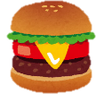  4 dollars | Fries  B  フライズ  3 dollars
Cola
C
コーラ
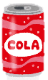
2 dollars
Menu 2
Sandwich  サンドイッチ  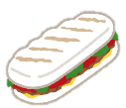  6 dollars | Cake  B  ケーキ  3 dollars
Boba
C
ボバ
4 dollars
A
Menu 3
Hot Dog  ホットドッグ  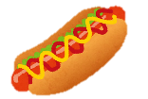  5 dollars | Chips  B  チップス  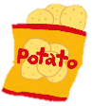  2 dollars
Juice
C
ジュース
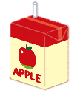
1 dollar
Menu 4
Sushi  A  スシ  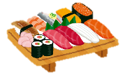  7 dollars | Edamame  B  エダマメ  1 dollar
Tea
C
ティー
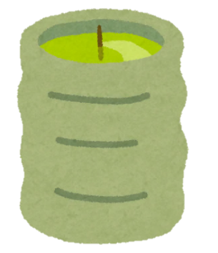
3 dollars

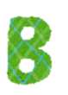
Can I have Menu ?
Which would you like, A or B ?
I’d like _____.
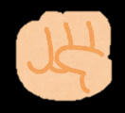
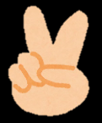
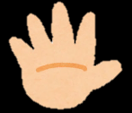
Rock scissors paper!

B wins!

A wins!

NO.
Sure. Anything else?
C please. How much is that in total?

In total, ____ dollars.
No circle.

Circle finished order.

Write down 1 order!
ホットドッグとコーラが欲しいです。
ホットドッグとコーラが欲しいです。
________________________________________________________________________________________________________________________________________________________________________________________________
それはごうけいでいくらですか？
Circle your order!
A
A
Menu 1
Hamburger  4 dollars | Fries  B  3 dollars
Cola
C
2 dollars
Menu 2
Sandwich  6 dollars | Cake  B  3 dollars
Boba
C

4 dollars
A
Menu 3
Hot Dog  5 dollars | Chips  B  2 dollars
Juice
C

1 dollar
Menu 4
Sushi  A  7 dollars | Edamame  B  1 dollar
Tea
C

3 dollars

