Hi, how are you?

I’m fine, thanks, and you?

I’m good, thanks.

What time did you get up?

I got up at six thirty. And you?

I got up at 5:00.

Wow! So early! What did you do?

I made breakfast. I made an omelet. It was delicious. What did you eat?

I ate rice and miso soup. It was good.

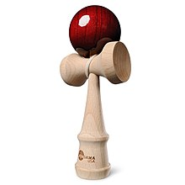
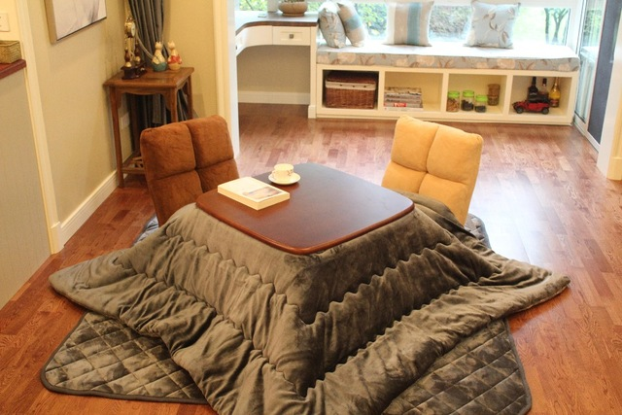
Cool. Did you make it?

