Unscramble the words
ex. giaten → eating

1. swne
2. ytsmro
3. tweerah
4. gtahtsir
5. trihg
6. leami
________________________
________________________
________________________
________________________
________________________
________________________

Draw a picture of each word

getting on the train | music program | rainy
turn off your cell phone | windy | across the street

Write the directions to the post office. Start at the train station.

Main St.
3rd St.
1st St.
2nd St.
Train Station
Park
Bank
School
Post
Office

______________________
______________________
______________________
______________________
______________________
______________________
______________________
______________________
______________________
______________________

Two people go to a teacher. Read the conversation on page 45.

Unscramble the sentences

1. Me the to could tell you way bank the ?
________________________________________________________

2. Time here will be you on ?
________________________________________________________

3. TV kind you like what do of programs ?
________________________________________________________

4. Usually in cold it’s Sapporo .
________________________________________________________

5. Next the supermarket it’s to .
________________________________________________________

Fill in the blank

1. ______________ the bridge.

2. Can I talk _________ you now?

3. Do you like ____________ TV?

4. What is the weather ________________ for tomorrow in Nara?

5. __________ is your favorite actor?

Two people go to a teacher. Read the conversation on page 54.

Answer the questions

1. How is the weather in Tokyo today?
________________________________________________________

2. Are you free?
________________________________________________________

3. Who is your favorite actor?
________________________________________________________

4. Do you like watching TV?
________________________________________________________

5. How is the climate in Osaka in this season?
________________________________________________________

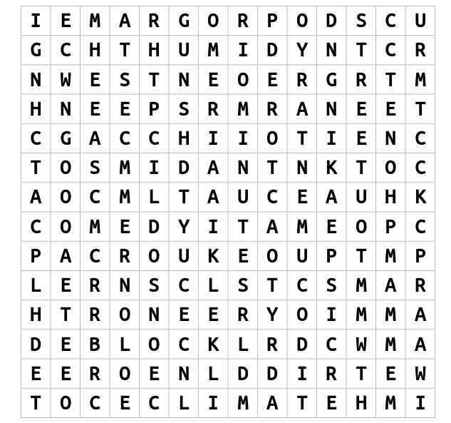
Word search

DRY
HUMID
CLIMATE
DOCUMENTARY
COMEDY
ACTOR
PHONE
MINUTE
SPEAKING
NORTH
WEST
BLOCK
STREET
WET
PROGRAM

Go to a teacher. Answer their question.

