Name ( ) No.( ) Class ( )-( )

『〜すること』を表す動詞ing
I like listening to music.
I enjoy playing the piano.

 | reading  comic books | playing video games | using a computer | speaking English | dancing
I like ~
I finished ~
I enjoy ~
I stopped ~
I’m good at ~

1 | 2 | 3 | 4 | 5 | 6 | 7 | 8 | 9 | Total
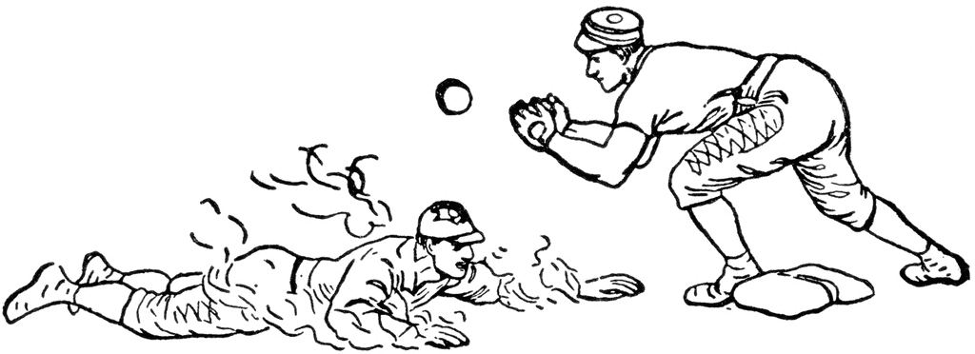

HR (2) 5点 1B (5) 1点 2B (4) 2点 3B (3) 3点 SO (2) -5点
* ( ) 個数

Writing ~ Write about your friends.

(例) Ron likes using a computer.

- _________________________________________________________________________
- _________________________________________________________________________
- _________________________________________________________________________
- _________________________________________________________________________
- _________________________________________________________________________

