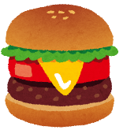  hamburger | 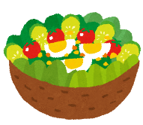  salad | 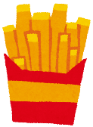  fries | 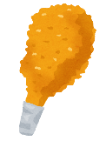  fried chicken | 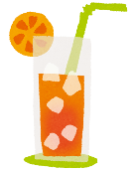  juice
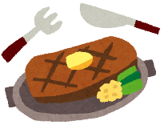  steak | green tea | 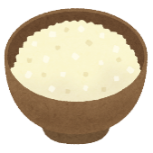  rice | ice cream | coffee
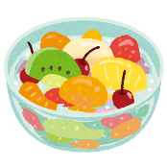  fruit | 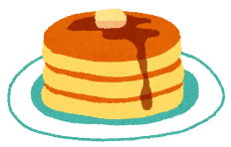  pancakes | FREE | soup | 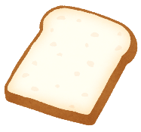  bread
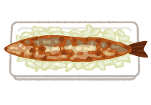  grilled fish | 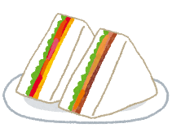  sandwich | cake | 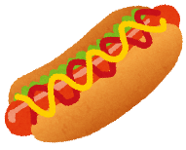  hotdog | 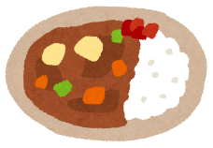  curry
parfait | 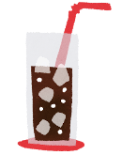  cola | yogurt | 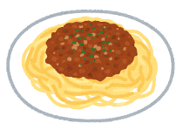  pasta | 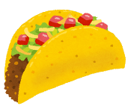  taco

hotdog | pasta | rice | salad | parfait
juice | yogurt | fries | grilled fish | curry
soup | hamburger | FREE | fruit | coffee
sandwich | ice cream | steak | bread | pancakes
cola | cake | fried chicken | taco | green tea

taco | ice cream | cola | pasta | fruit
bread | fries | yogurt | steak | hamburger
fried chicken | curry | FREE | parfait | sandwich
coffee | rice | juice | pancake | grilled fish
cake | soup | hotdog | green tea | salad

soup | juice | steak | ice cream | sandwich
yogurt | cola | pancakes | taco | coffee
grilled fish | bread | FREE | fries | fruit
hamburger | salad | pasta | parfait | fried chicken
curry | green tea | rice | cake | hotdog

bread | pancakes | fruit | grilled fish | soup
cola | ice cream | pasta | yogurt | curry
cake | hotdog | FREE | green tea | juice
salad | fried chicken | parfait | sandwich | coffee
fries | rice | taco | hamburger | steak

parfait | cake | hotdog | green tea | curry
pancakes | cola | fried chicken | rice | grilled fish
ice cream | fruit | FREE | hamburger | pasta
juice | steak | taco | yogurt | fries
sandwich | salad | bread | soup | coffee

curry | coffee | rice | bread | steak
yogurt | pasta | hamburger | hotdog | fries
green tea | taco | FREE | fried chicken | cola
grilled fish | parfait | soup | pancakes | juice
fruit | ice cream | sandwich | salad | cake

green tea | rice | bread | hotdog | coffee
fried chicken | taco | soup | cola | salad
curry | pasta | FREE | parfait | yogurt
fruit | cake | hamburger | ice cream | steak
grilled fish | pancakes | juice | fries | sandwich

