Example(例)
Q: Do you like Nobita?
A: O ⇨ Yes, I do.
X ⇨ No, I don’t,
but I like Doraemon.

Do you ~?
want a dog?  YES NO  Sign: | have a cute pen case?  YES NO  Sign: | play Splatoon 3?  YES NO  Sign: | eat ramen?  YES NO  Sign:
eat dog food?  YES NO  Sign: | speak Chinese?  YES NO  Sign: | play table tennis?  YES NO  Sign: | like summer?  YES NO  Sign:
use a smartphone?  YES NO  Sign: | have a PS5?  YES NO  Sign: | 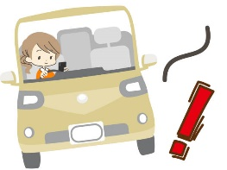  drive a car?  YES NO  Sign: | like heavy metal?  YES NO  Sign:
play basketball?  YES NO  Sign: | watch Precure?  YES NO  Sign: | study English?  YES NO  Sign: | want homework?  YES NO  Sign:

Challenge!! Write 3 sentences about your friends:
Example (例): Ms. Ishishiro eats ramen. / Brent does not eat dog food.
- .
- .
- .

