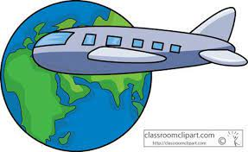
Name:_____________________________ Class:_______________ Number:______________

Plan a Trip

Activity 1: Name as many countries as you can, at least one from each continent.

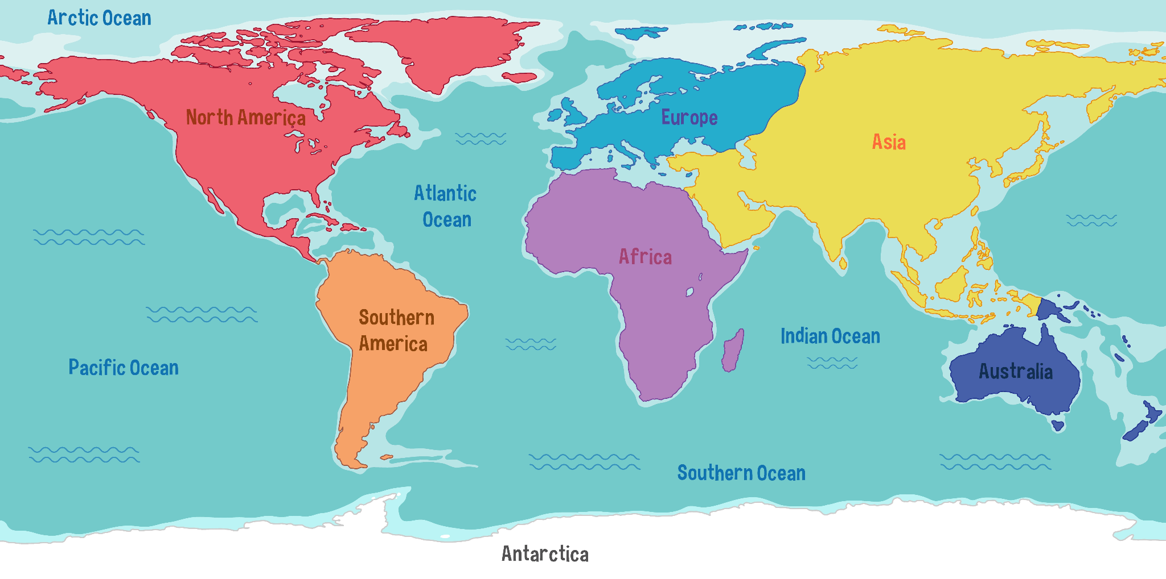

Activity 2: Write down your 3 favorite countries and what language they speak. Do not say Japan or U.S.A.! Then talk in a group and decide which country you will go to.

Country 1:____________________
Country 2:____________________
Country 3:____________________

Group’s country: _____________________

Why do you want to go there?______________________________
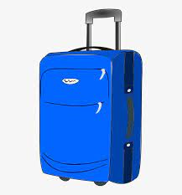

Activity 3: Packing
As a group, decide what you will take with you on your trip.

Key words: luggage=荷物

In my luggage I will pack_____________________________________ _______________________________________________________.

Some ideas: coat, sunblock (日焼け止め), toothbrush, phone, camera…

Activity 4: Presentation

Our group decided we want to go to ______________. We want to go there

because_______________________________. We will pack _________

_______________________ for our trip. When we are there, we want to

__________________________. We are very excited to go!

Please take notes here when other groups are presenting:

