Where are they originally eaten?

Learn about some famous dishes from around the world. Of course you can enjoy some of these in Japan, but we are talking about the ORIGINAL flavour!
Bon Appetit!
Let’s start!
- Beavertails | - Tarte tatin  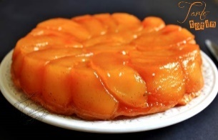 | - Steak and kidney pie  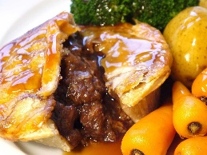
_______________ | _______________ | _______________

- Paella | - Fried spider  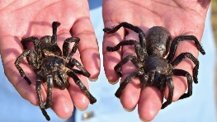 | - Currywurst
_______________ | _______________ | _______________
- Ceviche | - Nasi Lemak  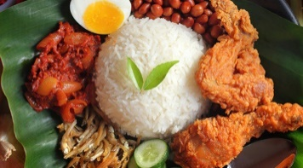 | - Pavlova
_______________ | _______________ | _______________

Questions
- What do you want to try the most? ______________________________
- Which dish looks the most delicious? ______________________________
- What can be eaten in Europe? _______________________________________

Name ( ) Class ( ) No ( )

