* **EMOJI BRAINTEASER ★**

Hints:

* Maybe the character likes it
* Maybe the character wears it
* Maybe the character has it or not
* Maybe the character is from there
* Maybe it’s the character’s name

GOOD LUCK!

Task: Who is the character?

* example:

|  |  |  |
| --- | --- | --- |
| 🧽 Sponge Emoji | Blue Square on Apple iOS 13.2 | 🩲 Briefs Emoji |
| It’s ___________________ | | |

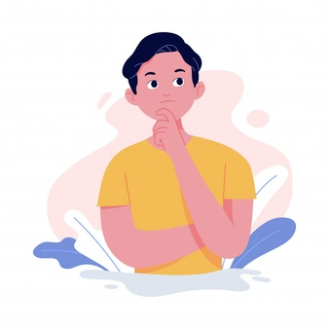Question 1

|  |  |  |  |  |
| --- | --- | --- | --- | --- |
| Woman Saying No Emoji [Free Download IOS Emojis] | Emoji Island | 絵文字 スタイルでの Ear のアイコン | Happy Cat Emoji [Download iPhone Emojis in PNG] | Emoji Island | ドア 絵文字 🚪 | 🇯🇵 Flag: Japan Emoji on Apple iOS 11.3 |
| It’s __________________________________ | | | | |

Memo (English / Japanese OK)

Question 2

|  |  |  |  |  |
| --- | --- | --- | --- | --- |
|  | Eye Emoji [Free Download All Emojis] | Emoji Island  1 or 2 | Crazy Face Emoji (U+1F92A) |  | United States Emoji (U+1F1FA, U+1F1F8) |
| It’s __________________________________ | | | | |

Question 3

Memo (English / Japanese OK)

|  |  |  |  |  |
| --- | --- | --- | --- | --- |
| 🧱 Brick Emoji | 👔 Necktie Emoji on Apple iOS 11.3 | 絵文字 🥚 卵 コピー/貼り付け | wpRock | 🚨 Police Car Light Emoji on Apple iOS 10.2 | 🇬🇧 Flag: United Kingdom Emoji on Apple iOS 11.2 |
| It’s __________________________________ | | | | |

Question 4

Memo (English / Japanese OK)

|  |  |  |  |  |
| --- | --- | --- | --- | --- |
|  |  | 🪵 Wood Emoji on Apple iOS 14.2 | Cowboy Emoji Png, Transparent Png , Transparent Png Image - PNGitem | United States Emoji (U+1F1FA, U+1F1F8) |
| It’s __________________________________ | | | | |

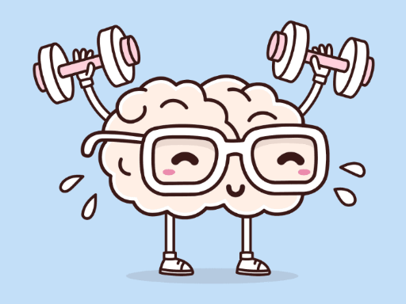

Question 5

|  |  |  |  |  |
| --- | --- | --- | --- | --- |
| 🐭 Mouse Face Emoji on Apple iOS 10.3 | Evergreen Tree Emoji (U+1F332) | ketchup | emojidex - custom emoji service and apps | High Voltage Emoji ⚡ | 🇯🇵 Flag: Japan Emoji on Apple iOS 11.3 |
| It’s __________________________________ | | | | |

Name ( ) Class ( ) No ( )