Name: ___________________ Class: ____ Number: ____ Date: ___/___
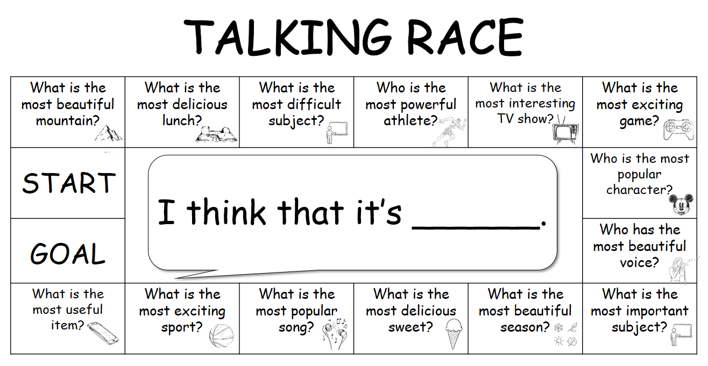

WRITING TIME


 



 



 



 




