1 2 3 | 4 5 6
He | She
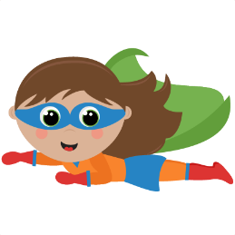
can… | 1 | fly
 | 2 | jump 10 meters
 | 3 | lift 1000 kg
 | 4 | drink Aojiru
 | 5 | make fire
 | 6 | swim

can play… | 1 | basketball
 | 2 | tennis
 | 3 | the piano
 | 4 | soccer
 | 5 | sumo
 | 6 | volleyball

can’t… | 1 | sleep
 | 2 | speak
 | 3 | drink water
 | 4 | go to Family Mart
 | 5 | move
 | 6 | use a computer

can eat… | 1 | rocks
 | 2 | stars
 | 3 | natto
 | 4 | ice cream
 | 5 | elephants
 | 6 | ants

- ______________________
- ______________________
- ______________________
- ______________________
Name: _______________
- ______________________
- ______________________
- ______________________
- ______________________
Name: _______________

