Let’s Interview a Foreign Person
A: Hello. What’s your name?
B: Hello, I’m ________ from _______?
How about you?
A: I’m ________ from _______?
What time do you ____________?
B: I ______________ at ____________.
What time do you ____________?
A: I ______________ at ____________.

.

自分
名前
国

名前
国
すること

時
すること
すること

すること
時
What time do you _____________?
_____________  名前  国  _____________ | _____________  _____________ | _____________  _____________ | _____________  _____________
get up
eat lunch
go home
take a bath
go to bed

Name: Emily
Country: Singapore
get up | 6:45am
eat breakfast | 7:05am
go to school | 8:10am
study English | 11:35am
eat lunch | 12:50pm
go home | 3:40pm
do your homework | 4:55pm
eat dinner | 7:15pm
take a bath | 8:00pm
go to bed | 10:35pm

Food
chicken rice

Animals
birds and rabbits

Sport
baseball

What _________ do you like?

food
animals
sport

Let’s Interview a Foreign Person
A: Hello. What’s your name?
B: Hello, I’m ________ from _______?
How about you?
A: I’m ________ from _______?
What time do you ____________?
B: I ______________ at ____________.
What time do you ____________?
A: I ______________ at ____________.

.

自分
国
名前
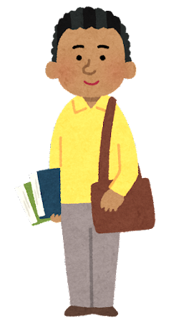
名前
国
すること

時
すること
すること

時
すること
What time do you _____________?
_____________  名前  国  _____________ | _____________  _____________ | _____________  _____________ | _____________  _____________
eat breakfast
study English
eat lunch
go home
go to bed

Name: Mike
Country: America
get up | 6:15am
eat breakfast | 6:45am
go to school | 7:50am
study English | 9:30am
eat lunch | 12:25pm
go home | 2:30pm
do your homework | 3:20pm
eat dinner | 6:30pm
take a bath | 8:05pm
go to bed | 9:40pm

Food
pizza

Animals
bears and lions

Sport
basketball

What _________ do you like?

food
animals
sport

Let’s Interview a Foreign Person
A: Hello. What’s your name?
B: Hello, I’m ________ from _______?
How about you?
A: I’m ________ from _______?
What time do you ____________?
B: I ______________ at ____________.
What time do you ____________?
A: I ______________ at ____________.

.

自分
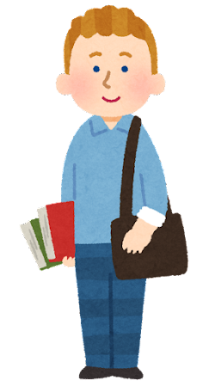
国
名前

名前
国
すること

時
すること
すること

時
すること
What time do you _____________?
_____________  名前  国  _____________ | _____________  _____________ | _____________  _____________ | _____________  _____________
get up
go to school
go home
eat dinner
take a bath

Name: Martin
Country: Sweden
get up | 5:30am
eat breakfast | 6:00am
go to school | 7:35am
study English | 10:05am
eat lunch | 12:20pm
go home | 3:15pm
do your homework | 4:00pm
eat dinner | 6:50pm
take a bath | 7:25pm
go to bed | 10:00pm

Food
meatballs

Animals
dogs and cats

Sport
soccer

What _________ do you like?

food
animals
sport

Let’s Interview a Foreign Person
A: Hello. What’s your name?
B: Hello, I’m ________ from _______?
How about you?
A: I’m ________ from _______?
What time do you ____________?
B: I ______________ at ____________.
What time do you ____________?
A: I ______________ at ____________.

.

自分
国
名前

名前
国
すること

時
すること
すること

時
すること
What time do you _____________?
_____________  名前  国  _____________ | _____________  _____________ | _____________  _____________ | _____________  _____________
go to school
go home
eat dinner
take a bath
take a bath

Name: Deepa
Country: India
get up | 7:00am
eat breakfast | 7:15am
go to school | 8:00am
study English | 11:25am
eat lunch | 12:35pm
go home | 3:50pm
do your homework | 4:30pm
eat dinner | 7:00pm
take a bath | 8:40pm
go to bed | 9:05pm

Food
curry and rice

Animals
cats and cows

Sport
cricket

What _________ do you like?

food
animals
sport

