

**. . . .**

**Dots & Boxes**

How to Play

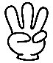鉛筆の無料イラスト | 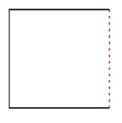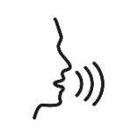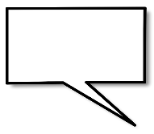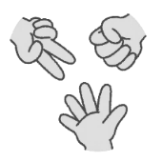

= -1

= +5

= +3

= +2

ROUND 2

**Player 1: ||||||||||||||||||||||| = |||||| points   
Player 2: ||||||||||||||||||||||| = |||||| points**

ROUND 1

The player with the most squares wins!  
最も多くの四角を獲得したプレイヤーが勝ちです！

How to WIN

**=**

- No diagonal lines.  
(ななめを書いてはいけません。)  
- Colour in your square.  
(四角が完成したら中に色をぬってね！)  
- If you complete a square, you can draw one more line!  
(四角が1つ完成したら、もう一本線を書くことができる！)

Make many  
squares!

5.

Draw a  
line!

4.

3.

Make a

Sentence!

[例] I like dogs.

RULES

Rock,

Paper

Scissors!

Choose

a

colour!

2.

1.