Bummer Cards
Keep this card.  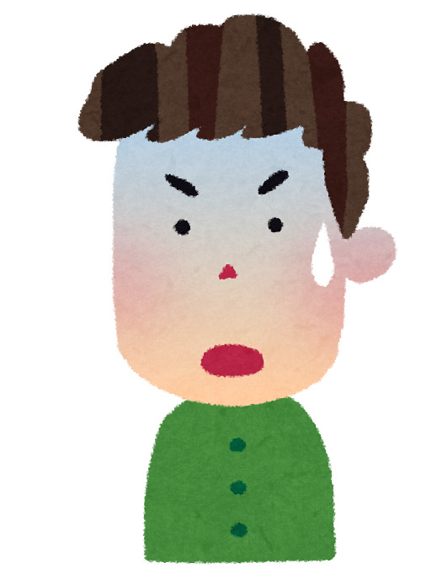  Change any rule. | Keep this card.  Change any rule. | Keep this card.  Change any rule. | Keep this card.  Change any rule.
Keep this card. | Keep this card. | Keep this card. | Keep this card.
Keep this card. | Keep this card. | Keep this card. | Keep this card.
Keep this card. | Keep this card. | Keep this card. | Keep this card.
⋆Lucky⋆  Give this card to another player. | ⋆Lucky⋆  Give this card to another player. | ⋆Lucky⋆  Give this card to another player. | ⋆Lucky⋆  Give this card to another player.

Take a bummer card every time you break a rule.
Rule:  Close your eyes whenever you talk.  Including reading! | Rule:  Clap (手を叩く) every time before you draw a card. | Rule:  Compliment (お世辞) someone every time before before your turn. | Rule:  No pointing (指差し).
Rule:  Stand up when it is your turn. | Rule:  Keep one hand on your desk. | Rule:  Make your own!  _______________ | Rule:  Make your own!  _______________

Take a bummer card every time you break a rule.
Rule:  Close your eyes whenever you talk.  Including reading! | Rule:  Clap (手を叩く) every time before you draw a card. | Rule:  Compliment (お世辞) someone every time before before your turn. | Rule:  No pointing (指差し).
Rule:  Stand up (立つ) when it is your turn. | Rule:  Keep one hand on your desk. | Rule:  Make your own!  _______________ | Rule:  Make your own!  _______________

Take a bummer card every time you break a rule.
Rule:  Close your eyes whenever you talk.  Including reading! | Rule:  Clap (手を叩く) every time before you draw a card. | Rule:  Compliment (お世辞) someone every time before before your turn. | Rule:  No pointing (指差し).
Rule:  Stand up when it is your turn. | Rule:  Keep one hand on your desk. | Rule:  Make your own!  _______________ | Rule:  Make your own!  _______________

PART 1 : Choose a card for your turn.
Mini game 1:  Say a word that starts with the letter of your choice.  Loser picks a bummer card. | Mini game 2:  Play rock, paper, scissors with a player of your choice.  Loser picks a bummer card. | Mini game 3:  Read this sentence and make it past tense.  I eat ramen. | Mini game 4:  Read this sentence and make it past tense.  I listen to music.
Mini game 5:  Make a sentence using these words:  go / They / together. / school / to | Mini game 6:  Make a sentence using these words:  walked / the / We / to / park. | Mini game 7:  Read this sentence and make it past tense.  I watch anime. | Mini game 8:  Read this sentence and make it past tense.  I go to school.
Mini game 9:  Make a sentence using these words:  is / at / She / swimming. / good | Mini game 10:  Make a sentence using these words:  He / to / cream. / likes / eat / ice | Mini game 11:  Read this sentence and make it present tense.  I played video games. | Mini game 12:  Read this sentence and make it present tense.  I painted a picture.
Mini game 13:  Make a sentence using these words:  really / My / likes / cat / tuna. | Mini game 14:  Make a sentence using these words:  night / I / English. / studied / Last | Mini game 15:  Read this sentence and make it present tense.  I drank milk. | Mini game 16:  Read this sentence and make it present tense.  I studied music.
Mini game 17:  Read this sentence and make it future tense.  I sang a song. | Mini game 18:  Read this sentence and make it future tense.  I am reading a book. | Mini game 19:  Read this sentence and make it future tense.  I did my homework. | Mini game 20:  Read this sentence and make it future tense.  I went to Tokyo.
Mini game 21:  Make a sentence using these words:  is / class / fun. / English | Mini game 22:  Read this sentence and make it present tense.  I felt happy. | Mini game 23:  Read this sentence and make it past tense.  I wash my hands. | Mini game 24:  Read this sentence and make it future tense.  I watched a movie.

PART 1 : Staple answer under question.
 |  | Answer 3:  I ate ramen. | Answer 4:  I listened to music.
Answer 5:  They go to school together. | Answer 6:  We walked to the park. | Answer 7:  I watched anime. | Answer 8:  I went to school.
Answer 9:  She is good at swimming. | Answer 10:  He likes to eat ice cream. | Answer 11:  I play video games. | Answer 12:  I paint a picture
Answer 13:  My cat really likes tuna. | Answer 14:  Last night, I studied English. | Answer 15:  I drink milk. | Answer 16:  I study music.
Answer 17:  I will sing a song. | Answer 18:  I will read a book. | Answer 19:  I will do my homework. | Answer 20:  I will go to Tokyo.
Answer 21:  English class is fun. | Answer 22:  I feel happy. | Answer 23:  I washed my hands. | Answer 24:  I will watch a movie.

Choose a card for your turn.
Cat Master:  Say “Cat”. Last one to make cat ears must copy you when you do an action of your choice. | Echo master:  Say “look right (右)”. Last to look has to echo a word you choose. | Cat Master:  Say “Cat”. Last one to make cat ears must copy you when you do an action of your choice. | Echo master:  Say “look left (左)”. Last to look has to echo a word you choose.

PART 2 : Choose a card for your turn.
Mini game 25:  Translate this sentence to English.  犬を２匹欲しいです。 | Mini game 26:  Translate this sentence to English.  今日は試験があります。 | Mini game 27:  Translate this sentence to Japanese.  My hobby is reading books. | Mini game 28:  Translate this sentence to Japanese.  I went to the beach.
Mini game 29:  Translate this sentence to English.  病院に行くべきです。 | Mini game 30:  Translate this sentence to English.  何をしているのか。 | Mini game 31:  Translate this sentence to Japanese.  I like Mexican food. | Mini game 32:  Translate this sentence to Japanese.  I want to be a teacher.
Mini game 33:  Answer the question:  What is today’s date?  (November first, second, third…) | Mini game 34:  Answer the question:  What day is today?  (Monday, Tuesday, Wednesday…) | Mini game 35:  Fill in the blank and read the sentence:  My favorite drink is _________. | Mini game 36:  Fill in the blank and read the sentence:  My favorite food is _________.
Mini game 37:  Answer the question:  What year is it?  (20_ _ ) | Mini game 38:  Answer the question:  What time is it?  (o’clock) | Mini game 39:  Fill in the blank and read the sentence:  My favorite movie is  _________. | Mini game 40:  Fill in the blank and read the sentence:  My favorite anime / manga is_________.

PART 2 : Staple answer under question.
Answer 25:  I want two dogs. | Answer 26:  I have a test today. | Answer 27:  趣味は読書です。 | Answer 28:  ビーチに行きました。
Answer 29:  I should go to the hospital. | Answer 30:  What are you doing? | Answer 31:  メキシコ料理が好きです。 | Answer 32:  先生になりたい。
Answer 33:  Today’s date is  ([Month] first, second, third…) | Answer 34:  Today is (Monday, Tuesday, Wednesday..) | Answer 35:  一番好きな飲み物 | Answer 36:  一番好きな食べ物
Answer 37:  It is 2023.  “Twenty twenty three or Two thousand twenty three” | Answer 38:  It is __ : __ __ o’clock. | Answer 39:  一番好きな映画 | Answer 40:  一番好きなアニメ・マンガ

Choose a card for your turn.
Cat Master:  Say “Cat”. Last one to make cat ears must copy you when you do an action of your choice. | Echo master:  Say “look right (右)”. Last to look has to echo a word you choose. | Cat Master:  Say “Cat”. Last one to make cat ears must copy you when you do an action of your choice. | Echo master:  Say “look left (左)”. Last to look has to echo a word you choose.

PART 3 : Choose a card for your turn.
Mini game 41:  Turn these words into a contraction:  I am | Mini game 42:  Make a sentence 5 words long using the word:  school | Mini game 43:  Correct the sentence:  She is go to the store. | Mini game 44:  Make the meaning negative (否定):  I have been to the United States.
Mini game 45:  Turn these words into a contraction:  Is not | Mini game 46:  Make a sentence 4 words long using the word:  hobby | Mini game 47:  Correct the sentence:  I like listen music. | Mini game 48:  Make the meaning negative (否定):  She will be here tomorrow.
Mini game 49:  Turn these words into a contraction:  We will | Mini game 50:  Make a sentence 6 words long using the word:  travel | Mini game 51:  Correct the sentence:  I have playing soccer since I was in middle school. | Mini game 52:  Make the meaning negative (否定):  They like homework.
Mini game 53:  Turn these words into a contraction:  They have | Mini game 54:  Make a sentence 3 words long using the word:  cats | Mini game 55:  Correct the sentence:  I like looking movies. | Mini game 56:  Make the meaning negative (否定):  We want to leave.
Mini game 57:
Read and answer the question:

Do you like this game?

PART 3 : Staple answer under question.
Answer 41:  I’m | Answer 42: | Answer 43:  She is going to the store. | Answer 44:  I have not/haven’t been to the United States.
Answer 45:  Isn’t | Answer 46: | Answer 47:  I like listening to music. / I like to listen to music. | Answer 48:  She will not / won’t be here tomorrow.
Answer 49:  We’ll | Answer 50: | Answer 51:  I have been playing soccer since I was in middle school. | Answer 52:  They do not / don’t like homework.
Answer 53:  They’ve | Answer 54: | Answer 55:  I like watching movies. | Answer 56:  We do not / don't want to leave.
Answer 57:
Yes, I do. / No, I don’t.

Choose a card for your turn.
Cat Master:  Say “Cat”. Last one to make cat ears must copy you when you do an action of your choice. | Echo master:  Say “look right (右)”. Last to look has to echo a word you choose. | Cat Master:  Say “Cat”. Last one to make cat ears must copy you when you do an action of your choice. | Echo master:  Say “look left (左)”. Last to look has to echo a word you choose.

