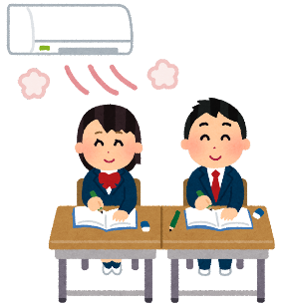

End of Second Year!

Time to reflect, and look forward to next year!

1. **What’s your favorite memory from the second year of junior high school?**

＿＿＿＿＿＿＿＿＿＿＿＿＿＿＿＿＿＿＿＿＿＿＿＿＿＿＿＿＿＿＿＿＿＿.

1. **What are you excited to do in your third year?**

＿＿＿＿＿＿＿＿＿＿＿＿＿＿＿＿＿＿＿＿＿＿＿＿＿＿＿＿＿＿＿＿＿＿.

1. **What did your classmates do that made you happy?**

＿＿＿＿＿＿＿＿＿＿＿＿＿＿＿＿＿＿＿＿＿＿＿＿＿＿＿＿＿＿＿＿＿＿.

1. **What is your advice for the 1st grade students?**

＿＿＿＿＿＿＿＿＿＿＿＿＿＿＿＿＿＿＿＿＿＿＿＿＿＿＿＿＿＿＿＿＿＿.



End of Second Year!

Time to reflect, and look forward to next year!

1. **What’s your favorite memory from the second year of junior high school?**

＿＿＿＿＿＿＿＿＿＿＿＿＿＿＿＿＿＿＿＿＿＿＿＿＿＿＿＿＿＿＿＿＿＿.

1. **What are you excited to do in your third year?**

＿＿＿＿＿＿＿＿＿＿＿＿＿＿＿＿＿＿＿＿＿＿＿＿＿＿＿＿＿＿＿＿＿＿.

1. **What did your classmates do that made you happy?**

＿＿＿＿＿＿＿＿＿＿＿＿＿＿＿＿＿＿＿＿＿＿＿＿＿＿＿＿＿＿＿＿＿＿.

1. **What is your advice for the 1st grade students?**

＿＿＿＿＿＿＿＿＿＿＿＿＿＿＿＿＿＿＿＿＿＿＿＿＿＿＿＿＿＿＿＿＿＿.