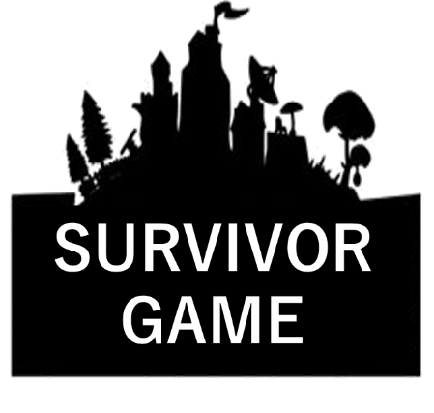
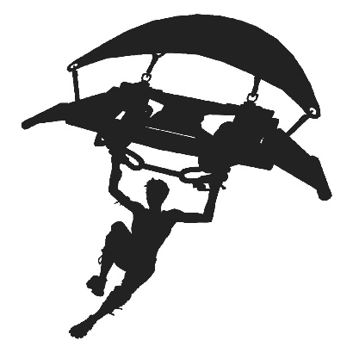
Name: ________________

ROUND ONE
When I ___________, ______________
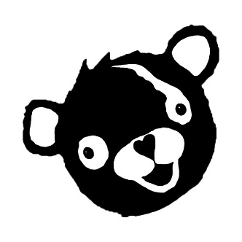
When I was at the park, I played soccer.
 | came to school | was 7 years old | visited my friend’s house | was at the park
played
saw
talked to
used
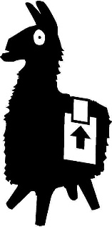
ROUND TWO
________________ when _______________.
I saw a movie when I went to Nagaoka.
 | came  home | was 12 years old | went to Nagaoka | was at  school
studied
met
watched
ate
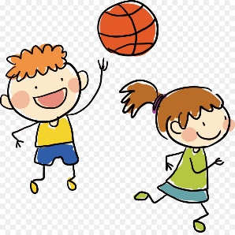
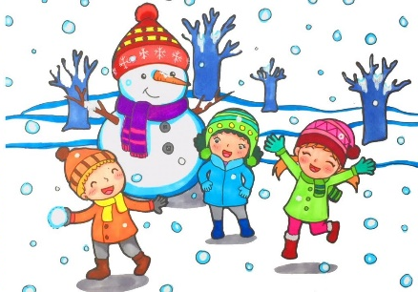
Name: ____________________
When I was…

in first grade at this school, | in second grade at my old school,
in sixth grade at my old school, | in first grade at my old school,
in fifth grade at my old school, | in kindergarten,
in fourth grade at my old school, | in the spring vacation,
in third grade at my old school, | a baby,

- __________________________________________________
__________________________________________________
__________________________________________________

- __________________________________________________
__________________________________________________
__________________________________________________

- __________________________________________________
__________________________________________________
__________________________________________________

- __________________________________________________
__________________________________________________
__________________________________________________

