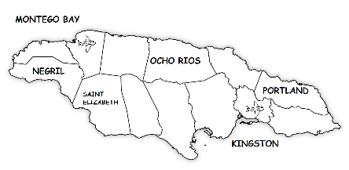
TRAVEL
PLAN
PLAN

JAMAICA

GUIDELINES
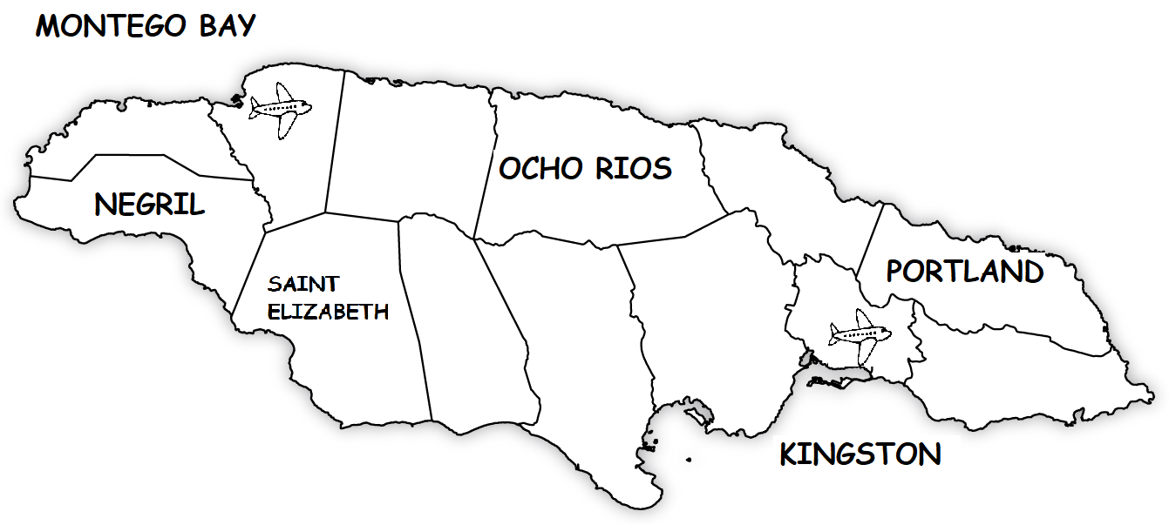
I want to go to (city).

I’m going to…
KINGSTON  - visit Bob Marley Museum  - eat ice cream at Devon House  - relax at Lime Cay | PORTLAND  - swim in Blue Lagoon  - raft in Blue Hole  - hike the Blue Mountains
OCHO RIOS  - climb the Konoko Falls  - climb Dunn’s River Falls  - relax on Bay Beach | MONTEGO BAY  - play paintball  - do ziplining  - do bobsledding
NEGRIL  - see the Y.S. Falls  - visit the Hummingbird Garden  - dive at Rick’s Café | SAINT ELIZABETH  - relax on Treasure Beach  - visit Appleton Estate  - visit the Rose Hall Great House

