Hi, how are you?

I’m fine, thanks, and you?

I’m good, thanks.

What did you do on Sunday?

I went to the Niigata. I went shopping.

Nice. Where did you go?

I went to Aeon Mall. It was busy. I bought a jacket.

Cool. Did you eat lunch there?

Yes, I did. I went to Kappazushi. It was delicious. Hope about you?

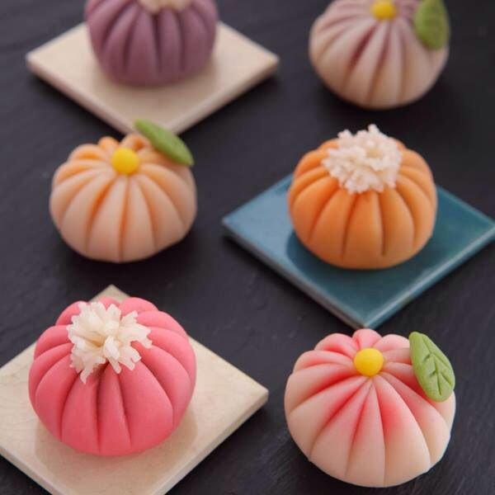
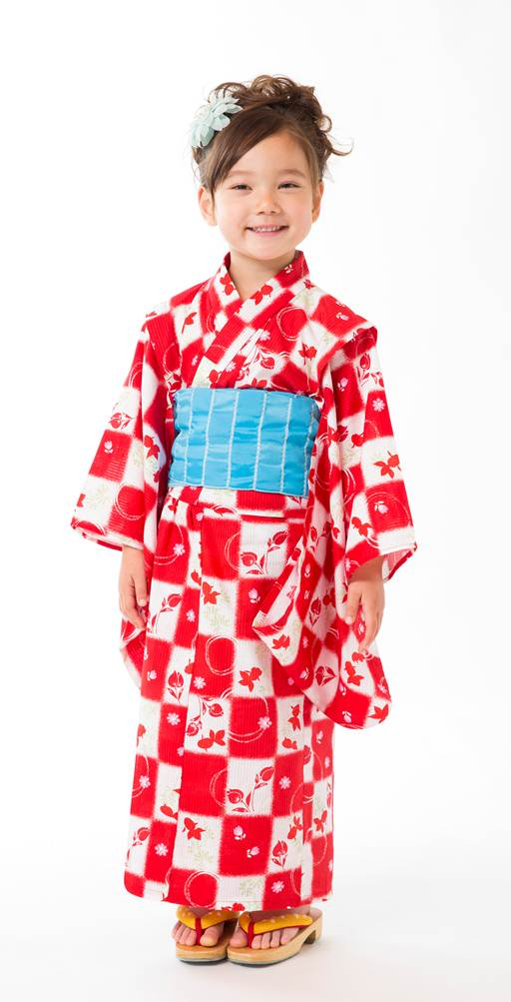
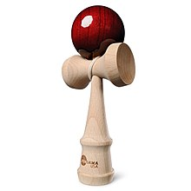
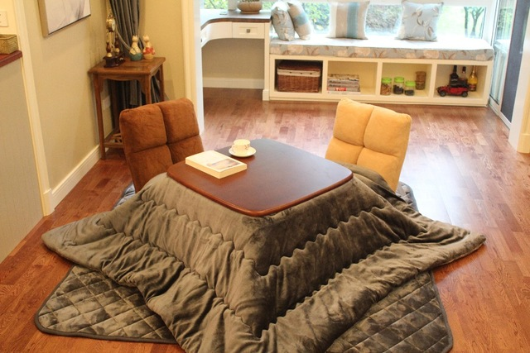
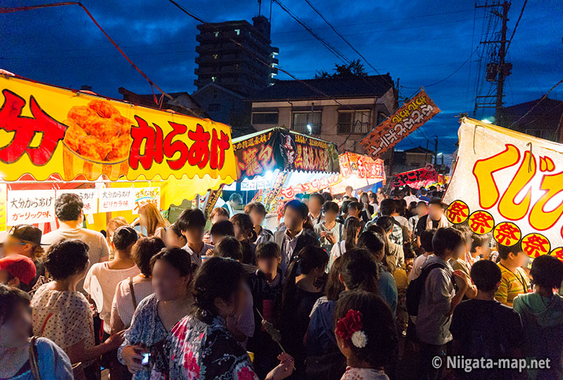
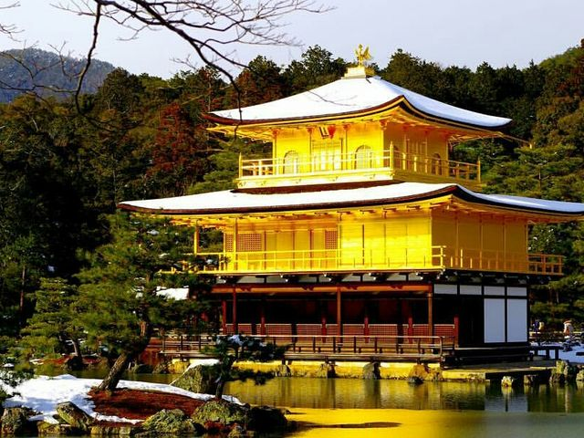
I went to the park with friends. We enjoy...

