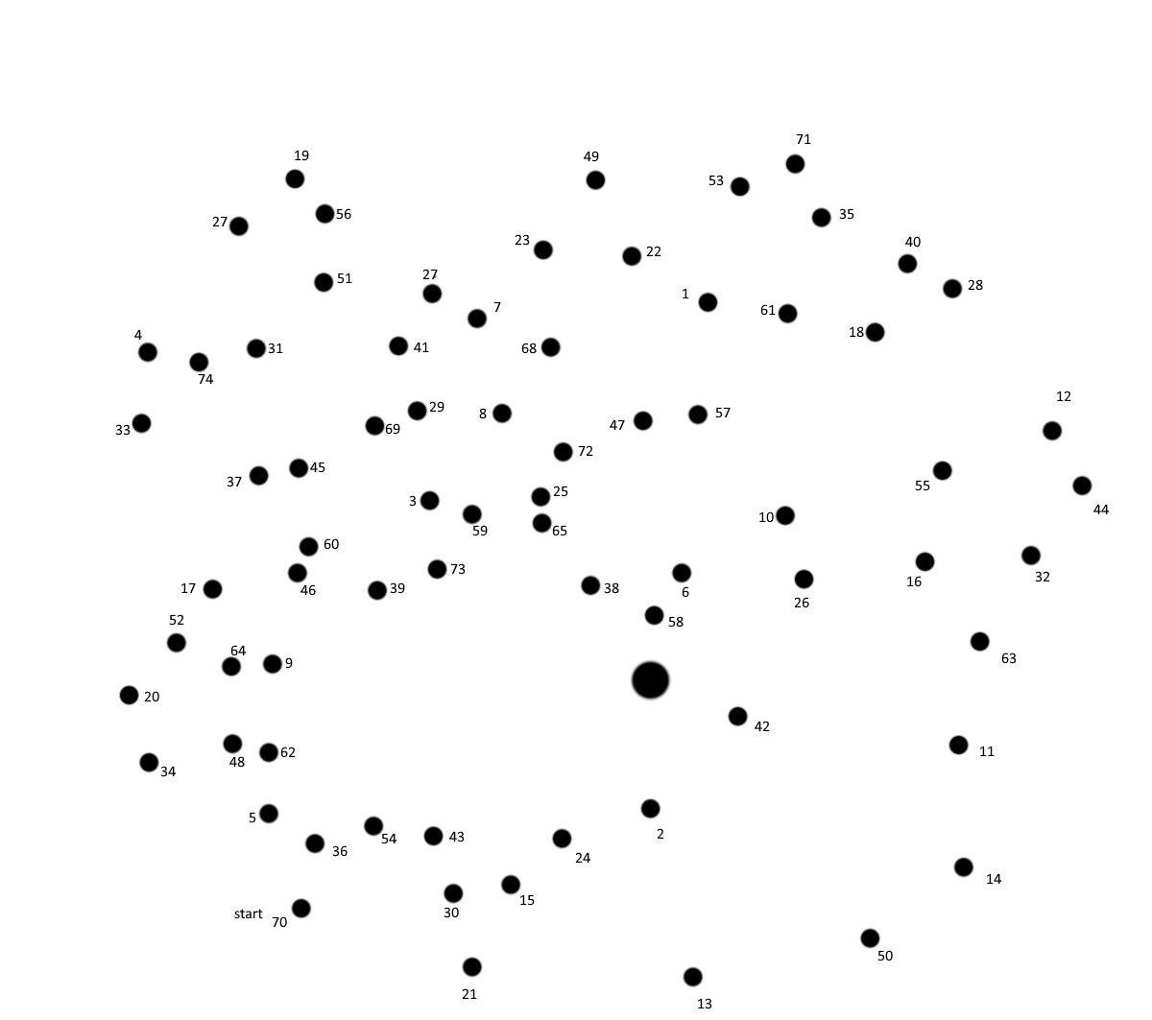

75

Name:_______________ ____________________________

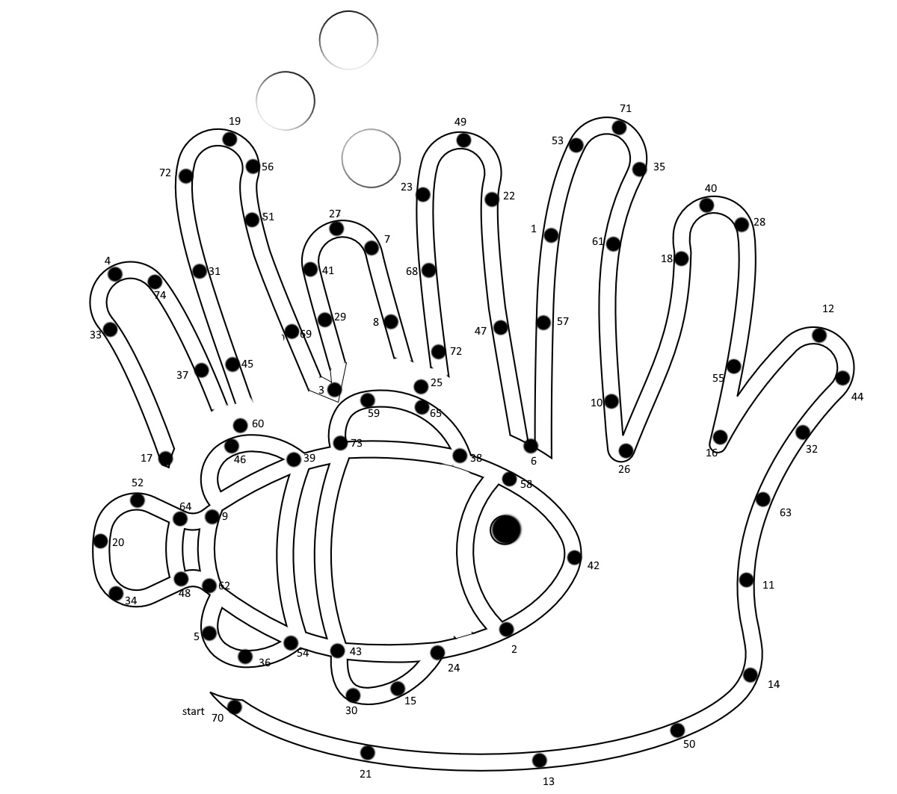

75