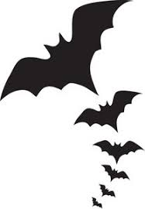
1.What is the other name for Halloween?
☐A. All Hollow’s Eve ☐B. All Hollow’s Day ☐C. All Hollow’s
2. What date is Halloween celebrated?
☐A. October 29 ☐B. October 30 ☐C. October 31
3. In which 3 countries did Halloween start?
☐A. Ireland ☐B. North France
☐C. United Kingdom ☐D. America
4. When did Halloween begin?
☐A. 3000 years ago ☐B. 2000 years ago ☐C. 200 years ago
5. People knock on doors and get candy. What is this activity called?
☐A. Trick or Treating ☐B. Pumpkin Carving
☐C. Wear costumes ☐D. Visit Haunted attractions
6. After carving the pumpkin, what do people put in it?
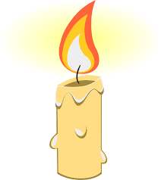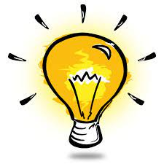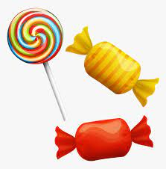
☐A. candle ☐B. bulb ☐C. candy
7.What is the name of the Celts festival that started Halloween?
☐A. Samhain ☐B. Sawhain ☐C. Sauhin

8. What are popular costumes around the world?
_________________________________________________________________________
_________________________________________________________________________
9. What activities do people do for Halloween?
_______________________________________________________________
_______________________________________________________________
Read the Halloween story and fill in the blanks.

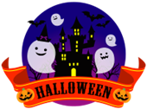
Why I love Halloween

Halloween is the best time to ______________________. The weather is ________________ and perfect. 2000 years ago, Celts would wear _________________ to scare away ghosts. Today, we still wear costumes. We knock on doors and say ____________________ and people give us a lot of _____________________.
This year, I will dress up as ____________________________or maybe ____________________________.
Families________________their houses with spiders and __________________.
My friends and I love to do _________________________ and we put candles inside pumpkins. That looks ________________ at night.
Have a ____________________ Halloween!

