Z | R | I | S | E | G | S | C | Y | B | D | X | H | L | Z | B
B | X | Z | C | H | E | F | W | D | G | I | F | U | D | J | O
C | A | U | W | V | B | I | B | V | K | W | Y | N | T | S | W
S | P | C | R | M | O | N | S | T | E | R | H | T | K | T | I
L | A | H | G | L | A | J | J | K | Z | E | T | E | F | O | R
A | V | I | U | C | I | I | T | U | H | B | E | R | F | B | Y
N | Q | Q | P | J | S | H | Z | B | U | K | D | O | E | I | Q
C | H | W | E | L | K | W | E | A | P | O | N | X | P | K | G
E | Y | G | G | X | R | L | A | F | N | O | C | B | H | A | Z
M | P | K | L | A | G | O | M | B | I | L | Y | V | O | D | D
D | Z | U | Z | O | M | S | T | R | M | F | B | J | N | A | S
N | H | A | L | Y | H | A | M | M | E | R | I | N | J | C | A
Q | M | O | X | T | P | N | U | M | Q | W | K | K | C | H | T
D | D | U | A | L | B | L | A | D | E | S | V | R | F | I | M
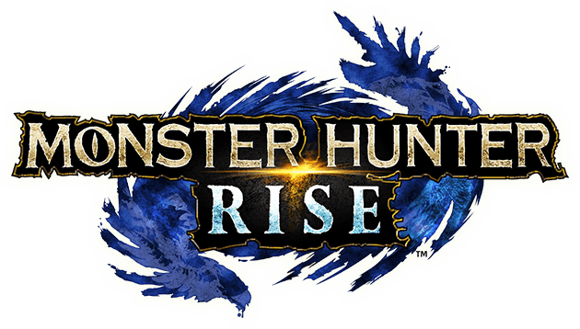
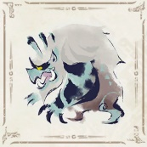
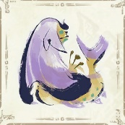
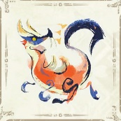
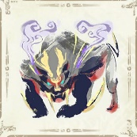
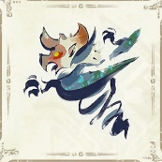
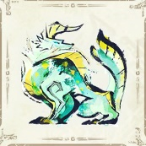
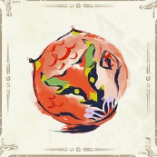
Word Search
オリジナルスタンプ
をゲット！

☐ MONSTER – モンスター ☐ DUAL BLADES – 双剣
☐ HUNTER – ハンター ☐ IZUCHI – イズチ
☐ RISE – ライズ ☐ TOBI KADACHI – トビカガチ
☐ WEAPON - 武器 ☐ LAGOMBI – ウルクスス
☐ HAMMER – ハンマー ☐ KEZHU – フルフル
☐ BOW – 弓
☐ LANCE – ランス

