This is…
Please draw your own original character in the box below! You can make them anything you want. Be creative!

Now, let’s introduce your character!

This is _________________________________________________________

He/she is ______________________________________________________

He/she is not __________________________________________________
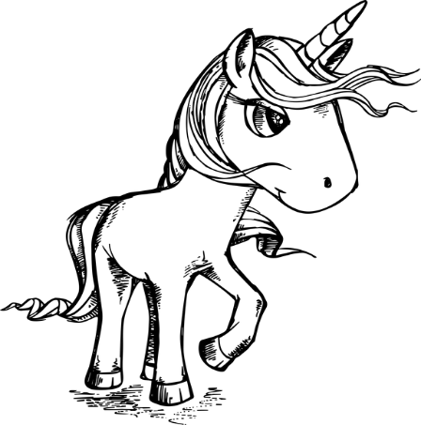
例:
This is Princess Unicorn.
She is kind.
She is not from Kagoshima.

Toolboxes
You can use these words to help make your sentences, or you can find your own words in your textbook and tablet.
これらの単語を使って文章を作ったり、タブレットや教科書を使ったりしてください。
Nouns (名詞)
He/She is a…
Girl 女子
Boy 男子
Human 人間
Alien 宇宙人
Hero ヒーロー
Villain 悪役
Monster 妖怪
King 王様
Queen 女王
Dragon 竜
Ghost 幽霊

Adjectives (形容詞) He/She is…
Happy 嬉しい
Sad 悲しい
Angry 怒っている
Sleepy 眠い
Hungry お腹がすいた
Kind 優しい
Rude 荒い
Energetic 元気
Beautiful 美しい
Smart 利口な
Scary 怖い

Places (場所)
He/She is from…
Japan
China
Korea
UK
America
Canada
Australia
New Zealand
Spain
Italy
Earth 地球
Space 宇宙空間
The Moon お月様
Mars 火星

