Unit 1: I like \_\_\_\_\_\_\_. I don’t like \_\_\_\_\_\_\_\_\_.

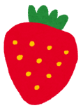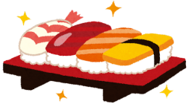

Food

|  |  |
| --- | --- |
| mark_face_asemark_face_laughI like… | I don’t like… |



Sports

|  |  |
| --- | --- |
| mark_face_laughI like… | mark_face_aseI don’t like… |

Colors [色]

|  |  |
| --- | --- |
| mark_face_laughI like… | mark_face_aseI don’t like… |