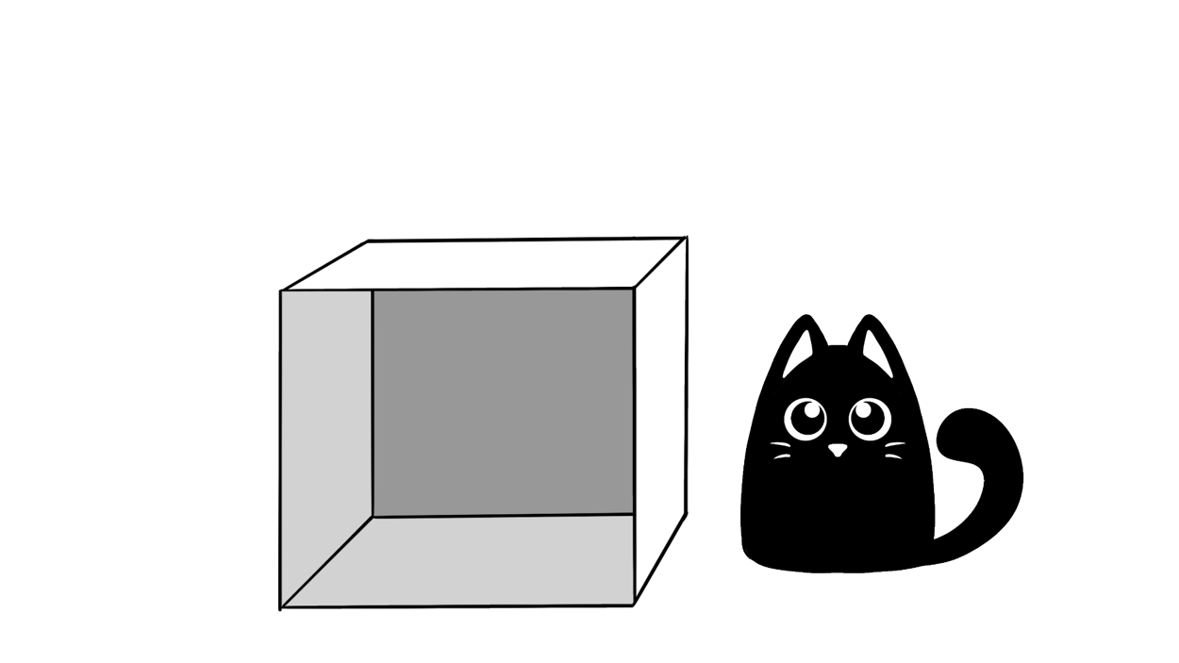

**Where is Mewo?**

* Ex: I found Mewo by the box.
* ________________________________________________________________________________
* ________________________________________________________________________________
* ________________________________________________________________________________
* ________________________________________________________________________________
* ________________________________________________________________________________
* ________________________________________________________________________________

**(behind)**

**under**

**in**

**on**

I found Mewo. . .

**by**

I found Mewo!